EXAMPLES
TECHNICAL ASSISTANCE AND CAPACITY BUILDING
FROM MEMBER NOTIFICATIONS

Last updated 9 JULY 2019

TABLE OF CONTENTS
Article 1: Publication and Availability of Information 1
1. Publication 1
Article 1: Publication and Availability of Information 4
2. Information Available Through Internet 4
Article 1: Publication and Availability of Information 7
3. Enquiry Points 7
Article 1: Publication and Availability of Information 10
4. Notification 10
Article 2: Opportunity to Comment, Information before Entry into Force and Consultations 12
1. Opportunity to Comment and Information before Entry into Force 12
Article 2: Opportunity to Comment, Information before Entry into Force and Consultations 14
2. Consultations 14
Article 3: Advance Rulings 16
Article 4: Procedures for Appeal or Review 18
Article 5: Other Measures to Enhance Impartiality, Non-Discrimination and Transparency 20
1. Notifications for Enhanced Controls or Inspections 20
Article 5: Other Measures to Enhance Impartiality, Non-Discrimination and Transparency 23
2. Detention 23
Article 5: Other Measures to Enhance Impartiality, Non-Discrimination and Transparency 25
3. Test Procedures 25
Article 6: Disciplines on Fees and Charges Imposed on or in Connection with Importation and Exportation and Penalties 28
1. General Disciplines on Fees and Charges Imposed on or in Connection with Importation and Exportation 28
Article 6: Disciplines on Fees and Charges Imposed on or in Connection with Importation and Exportation and Penalties 30
2. Specific Disciplines on Fees and Charges for Customs Processing Imposed on or in Connection with Importation and Exportation 30
Article 6: Disciplines on Fees and Charges Imposed on or in Connection with Importation and Exportation and Penalties 32
3. Penalty Disciplines 32
Article 7: Release and Clearance of Goods 34
1. Pre-arrival Processing 34
Article 7: Release and Clearance of Goods 36
2. Electronic Payment 36
Article 7: Release and Clearance of Goods 38
3. Separation of Release from Final Determination of Customs Duties, Taxes, Fees and Charges 38
Article 7: Release and Clearance of Goods 40
4. Risk Management 40
Article 7: Release and Clearance of Goods 44
5. Post-Clearance Audit 44
Article 7: Release and Clearance of Goods 47
6. Establishment and Publication of Average Release Times 47
Article 7: Release and Clearance of Goods 50
7. Trade Facilitation Measures for Authorized Operators 50
Article 7: Release and Clearance of Goods 53
8. Expedited Shipments 53
Article 7: Release and Clearance of Goods 55
9. Perishable Goods 55
Article 8: Border Agency Cooperation 57
Article 9: Movement of Goods Intended for Import under Customs Control 60
Article 10: Formalities Connected with Importation, Exportation And Transit 61
1. Formalities and Documentation Requirements 61
Article 10: Formalities Connected With Importation, Exportation And Transit 64
2. Acceptance of Copies 64
Article 10: Formalities Connected With Importation, Exportation And Transit 66
3. Use of International Standards 66
Article 10: Formalities Connected With Importation, Exportation And Transit 68
4. Single Window 68
Article 10: Formalities Connected With Importation, Exportation And Transit 75
5. Pre-shipment Inspection 75
Article 10: Formalities Connected With Importation, Exportation And Transit 76
6. Use of Customs Brokers 76
Article 10: Formalities Connected With Importation, Exportation And Transit 77
7. Common Border Procedures and Uniform Documentation Requirements 77
Article 10: Formalities Connected With Importation, Exportation And Transit 78
8. Rejected Goods 78
Article 10: Formalities Connected With Importation, Exportation And Transit 79
9. Temporary Admission of Goods and Inward and Outward Processing 79
Article 11: Freedom of Transit 81
Article 12: Customs Cooperation 84

Introduction

This document presents some examples of technical assistance and support for capacity building (TACB) requirements from Members' notifications received as of 19 July 2019. The examples have been selected randomly across different geographical regions and from Members at different levels of development.

Used in conjunction with Member's needs assessment results, these examples can provide inspiration to help you identify the TACB requirements that reflect your specific situation, your starting point and your intentions for implementation.

In addition, a chart showing a compilation of generic categories of TACB needs that have been identified in Members' notifications is provided for each provision. These charts are taken from http://www.tfadatabase.org as of 19 July 2019.

By presenting this document the WTO Secretariat is not making any recommendations on how the provisions of the Trade Facilitation Agreement (TFA) should be implemented. For further examples, Member's notifications can be found at https://www.tfadatabase.org/members.

NOTIFICATION GENERIC CATEGORIES

The following notification examples submitted by Members will follow with a chart reflecting the top themes found in received notifications.

The categories are as follows :

Information and Communication Technologies (ICT)
May occur following the decision to construct or acquire facilities and accommodation, and install and upgrade new or additional implementation tools, including information and communication technologies (ICTs) such as virtual networks, automated solutions, and scanners. ICTs have been identified in a number of case stories on trade facilitation reforms as one of the key factors in enhancing the effectiveness and efficiency of a number of specific trade facilitation measures, such as x-ray scanners to complement risk management procedures and computerized system to submit electronically and process pre-arrival documents.

Infrastructure and Equipment
May occur following the decision to construct or acquire facilities and accommodation, and install and upgrade new or additional implementation tools. Although equipment and infrastructure do not always constitute a prerequisite to implement most trade facilitation measures, they are usually considered to be the most expensive components of trade facilitation reform.

Legislative and regulatory framework
May occur when existing pieces of national legislation have to be amended or a new legislation has to be adopted in order to implement specific trade facilitation measures. For instance, in the absence of laws recognising the legal status of electronic documentation, any electronic documents must continue to be accompanied by its paper equivalent. A change in the legislation is therefore often required to authorize and recognize the validity of electronic data submission between agencies and digital signatures. Such costs usually involve time (depending on the country’s legal framework), staff specialized in legislative and regulatory issues, and sometimes external experts.

Institutional procedures
May arise when new units have to be established or existing units have to be re-structured in order to perform specific trade facilitation functions more efficiently, either by redeploying existing staff or recruiting additional staff. For instance, the introduction of post-clearance audit, the application of risk management procedures or the establishment of a central enquiry point might require a dedicated team of administrative, operational and support staff.

Awareness-raising
May arise when transparency and communication strategies are implemented to promote a greater involvement of all relevant stakeholders in the public and private sectors, including through a better understanding of the trade facilitation reform’s elaboration and progress achieved. The support, participation and ownership of relevant stakeholders tend to facilitate not only the introduction, but also the sustainability of a number of trade facilitation measures.

Human resources and training
Arise when users in border management agencies and the trading community have to learn new ways of complying with the trade facilitation formalities and operations. Training is often viewed as the most important element in implementing trade facilitation measures, since trade facilitation reform is mainly about changing border agencies’ practices and behaviours. The level of training costs depends on whether new expert staff are hired, or whether internal or transferred staff are trained on the job or in a training centre. Recruiting new expert staff is usually considered to be the most costly option, because it not only often requires a budgetary increase but also the direct availability of skilled experts in the domestic labour market.

Diagnostic and Needs Assessment
Arise prior to the actual implementation of trade facilitation reform to identify the trade facilitation needs, set realistic reform priorities and prepare a practical implementation strategy. Diagnostic costs usually involve time and national and/or external experts to consult with relevant stakeholders and formulate concrete action plans based on the information collected.

To be determined
The Member has not yet provided the type of assistance it requires in its category C notification.

For an analysis of the technical assistance requested by a specific Member, please visit the Member profiles.

Article 1: Publication and Availability of Information

1. Publication
Quick Summary Notes
What activity does this proposal regulate?
The types of information that governments publish, and the manner of publication.
Which authorities are directly concerned?
- Executive Authority
- All border agencies
- Trade Authority
- Revenue Authority
What are the new requirements?
- Members shall publish the general trade-related information listed in the proposal
- Members shall publish such information "promptly" and in a "non-discriminatory and easily accessible manner" that will allow other governments, traders and interested persons to become acquainted with them.

Examples of External Technical Assistance and Capacity Building (TACB) from Member Notifications: BELIZE
- External Financial assistance to implement electronic version of Belize’s Customs tariffs and nomenclature and the electronic Customs Procedure Manual.
- Development of systems to safeguard and protect the authenticity of documents that are uploaded to avoid unauthorized use and manipulation.
- Diagnostic study on the relevance of the import licensing regime by product categories, so as to provide the scope for a modern policy/legal framework. Legal aid is required to proceed.
- Develop a trade portal requiring a functioning website for the Directorate General for Foreign Trade.
- Technical assistance to assess current infrastructure and recommendations for the development and implementation of an electronic trade management information system. Assistance should be inclusive of equipment and requisite training at all levels.
- External financial and technical assistance for a comprehensive information system for BAHA which will allow for electronic transactions and information sharing.
- External financial and technical assistance for the review and drafting of Sanitary and Phytosanitary regulations and bills.
- Technical assistance to ensure that the policy for the provision of trade and trade related information is in line with Government policies and regulations.
- Technical assistance needed to design a communications framework that meets the needs of BAHA and its stakeholders.
- Training and IT development/advancement.
- Technical and financial assistance to develop and implement a wide-area network for BAHA.

Examples of TACB from Member Notifications: FIJI
- Legal/Policy: Technical expertise to develop user friendly publications. Technical expertise in translating information in other 2 official languages.
- Procedures: Assistance is required to review the range of publications produced by border agencies and develop more formal procedures in order to publish trade related information in easily accessible manner and to provide measures to ensure that relevant agency staffs are aware of the obligation.
- Human Resources/Training: Training of all relevant border agency Officials to have better understanding of Fiji's international obligations, relevant domestic laws and roles and responsibilities of other border agencies to facilitate trade. The training will also include identification of type of information that the agencies need to publish.
- ICT: To develop user friendly websites where all relevant information could be found easily. Capacitate other border agencies with ICT systems.

Examples of TACB from Member Notifications: JAMAICA
Technical Assistance and Capacity Building TACB supported is required to:
- Review existing legislation;
- Identify and allocate resources to ensure timely publication;
- Develop and implement change management programmes in the public sector to effectively disseminate information;
- Develop public education content and campaigns, and develop standard operating procedures (SOP);
- Setup the central body to monitor and coordinate the dissemination of information, as well as the adoption of best practices;
- Train personnel;
- Develop competencies of relevant units responsible for publication of information;
- Provide ICT infrastructure, including website development and agency linkages.

Examples of TACB from Member Notifications: NIGERIA
- Support and proper guidance on availability of documents required by regulatory agencies for international trade operations, as well as the relevant documentary procedures.
- Support and proper guidance on availability of forms required by regulatory agencies for international trade operations.
- Training on online processes and procedures.
- Upgrading of specialized Trade Portal
- Support to expand Customs Website and other trade agencies to publish all information related to trade.
- Support to establish database to improve the low access of business and private sector to existing trade
- information and complaints.
- Analytical basis for the streamlining and decrease the number of documents.
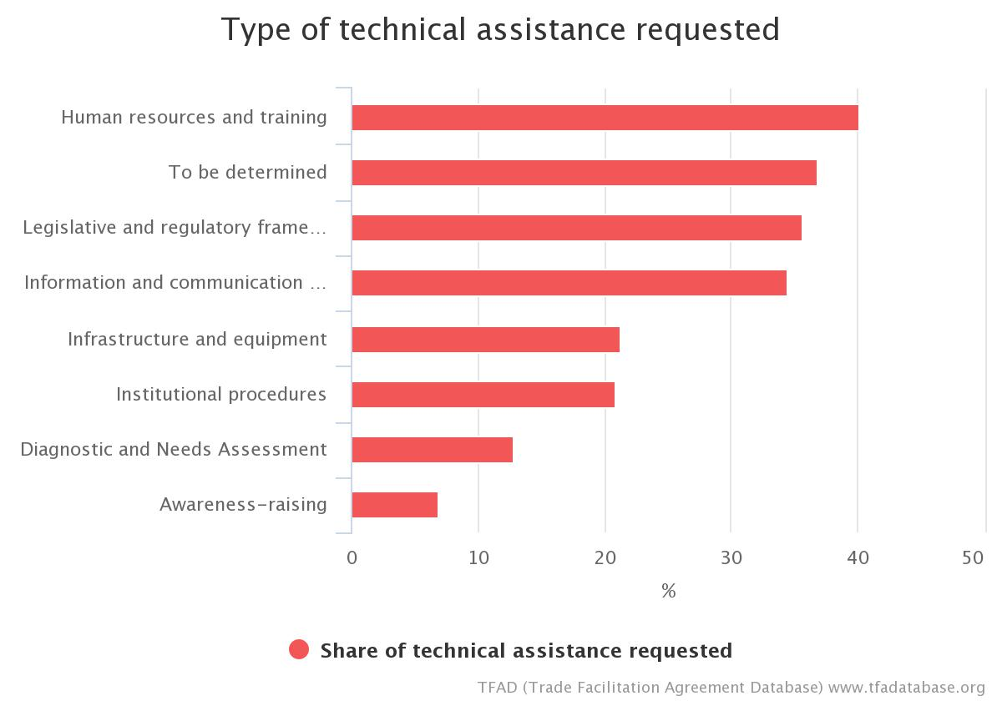
Article 1.1 Chart

Article 1: Publication and Availability of Information

2. Information Available Through Internet
Quick Summary Notes
What activity does this measure regulate?
The information a government provides to the public regarding import, export and transit procedures, and the manner by which it is provided.
Which authorities are directly concerned?
- Executive Authority
- All border agencies
- Trade Authority
What are the new requirements?
- Members shall prepare practical guides to their import, export, and transit procedures including appeal procedures
- Members shall publish on the internet:
- the practical guides,
- the documents or forms required for import, export or transit,
- relevant trade laws (where possible), and
- the enquiry point contact information.

Examples of TACB from Member Notifications: BELIZE
- Legal aid required to:
  - Develop policy (guided by international standards) and guidelines.
  - Revise/Amend or Repeal the existing laws to take into considerations publication provisions as prescribed under the AILP.
- Training on NTBs/WTO AILP.
- Technical assistance and financial support in area of IT for safeguarding and protecting the authenticity of documents that are uploaded to avoid unauthorized use and manipulation.
- Note: TACB identified in Art. 1.1 also applicable here.

Examples of TACB from Member Notifications: FIJI
- Legal/Policy: Require assistance to develop relevant legislations and policies in order to have information available through the internet.
- Procedures: To develop user friendly import and export checklist, guidelines on export and import fees and charges.
- Human Resources/Training: Training of IT Staff to design, develop and maintain websites
- ICT: Some agencies lack sufficient and competent technical staff required to maintain the relevant websites. There is a need in agencies for technical experts to incorporate and maintain the content on an existing internet site (or sites), and ultimately to design, develop and maintain a new website.
- Assistance required to develop one stop shop online information centre for import, export and transit for all agencies.
- Assistance required to develop multilanguage provision of information on government websites, including official languages.

- Infrastructure/Equipment: Assistance required to assist border agencies with relevant equipment and software programs. Also require necessary website content management information technology typically used for rapid amendment to websites that allows communication of changes to all interested parties.
Examples of TACB from Member Notifications: PAPA NEW GUINEA
- Technical assistance and capacity building needed to support information collation: Creation of a National trade portal where information identified in TFA Art.1.1 is made available; Procurement of Software, Hardware and IT Equipment for National trade portal; Upload information.

Examples of TACB from Member Notifications: SAINT VINCENT AND THE GRENADINES
- Assistance in creating an information management system and implementing web publication policy and guidelines.
- Procuring ICT equipment.

Examples of TACB from Member Notifications: SAMOA
- Legal/Policy: Undertake study to include stocktake of all trade information available online; identify gaps and assess Samoa's readiness to have a trade information portal/ website; cost and benefit analysis. Develop policy and legislate as necessary the mandate and process of publishing information; and having this information available online.
- Procedures: Review of outdated Standard Operating Procedures.
- Human Resources/Training: Training of IT Staff to design, develop and maintain websites Training of Customs officials on the implementation of Standard Operating
- Procedures: Relevant training of officials and private sector
- Information and Communication Technology: Develop and maintain a Trade Information Portal system (TIP)
- Infrastructure: Appropriate equipment and software programs for border agencies
- Consultations/Public Awareness: Stakeholder consultations on the potential TIP

Examples of TACB from Member Notifications: TRINIDAD AND TOBAGO
- ICT - Development of content for a Trade Information Portal
- Human Resource/Training – Train personnel
- Equipment - Equipment for infrastructural upgrades
Examples of TACB from Member Notifications: TOGO
- Development and implementation of policy guidelines on publication of trade-related information.
- Timely review and update of trade-related information on internet by the relevant agencies.
- Creation of a trade information portal.
- Institutional capacity building.
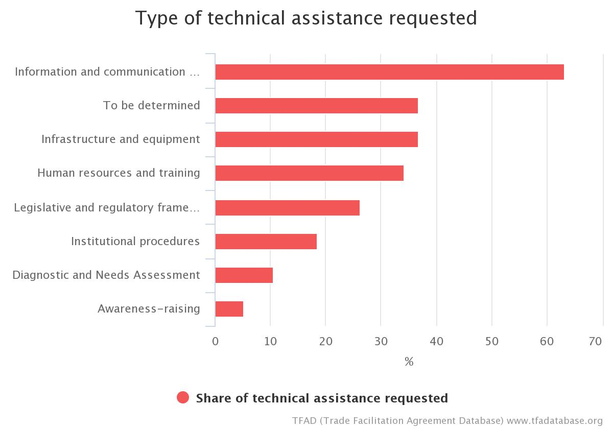
Article 1.2 Chart

Article 1: Publication and Availability of Information

3. Enquiry Points
Quick Summary Notes
What activity does this measure regulate?
The means by which an individual trader, a government, or any other interested person obtains specific information from a Member about import, export or transit requirements.
Which authorities are directly concerned?
- Executive authority
- All border agencies
- Trade Authority
What are the new requirements?
- A Member shall establish one or more "enquiry points" to respond to "reasonable" questions about the matters listed in Article 1.1, and to requests for required forms and documents.
If a member of a customs union or involved in regional integration, a Member may opt to participate in a regional enquiry point, rather than establishing a national enquiry point.
- The Member shall respond to such enquires and requests within a "reasonable" time.
- Members are encouraged not to charge fees for answering basic enquiries. Any fees charged for enquiries or for providing forms or documents shall be limited to the approximate cost incurred.

Examples of TACB from Member Notifications: BELIZE
- Develop within the Directorate General for Foreign Trade a Trade Portal for the amalgamation of enquiries and responses.
- Legally establish Trade information enquiry point designated as the Central authority within the Government.
- Legal drafter to amend/revise the existing legislation to identify the Supplies Control Unit as the official contact point with functions and responsibilities clearly defined in all matters relevant to import licensing

Examples of TACB from Member Notifications: BOTSWANA
- Undertaking an Information needs analysis and developing a suitable strategy to the needs
- Designating appropriate agencies or Departments
- Establishing standards and procedures of quality control including fixed timelines
- Training of personnel on service delivery
- Investment in the necessary hardware

Examples of TACB from Member Notifications : GUYANA
Article 1 : 3.2
- Technical Assistance required: Develop regional guidelines and standard operating procedures for the administration of a regional enquiry point.

Examples of TACB from Member Notifications: JAMAICA
- Technical Assistance and Capacity Building TACB supported is required to:
  - Train staff (including cross-training) in core competencies;
  - Train staff to utilize diverse response mechanisms including new and alternative media

Examples of TACB from Member Notifications: MAURITIUS
- Creation of an electronic information management platform at the Ministry of Agro Industry and Food Security.
- Development and Implementation of a Food Import Management System (FIMIS) at the Ministry of Health and Quality of Life.
- Recruitment and capacity building of staff as Inspectors at Mauritius Standards Bureau (MSB) in the following field: Rice & Flour, Food and Agriculture (Expert), Cement (Civil Engineer), Petrol (Chemical Engineer)
- Changing of legal and/or regulatory framework.
- Acquisition of ICT and other equipment.
- Training & Capacity Building.

Examples of TACB from Member Notifications: PAPA NEW GUINEA
- Technical assistance and capacity building is also required to explain the roles and responsibilities of enquiry points. Technical assistance also required to review institutional setups and support for legislative change to give effect for the establishment of Enquiry Points (of at least two officers) in each of the following Agencies:
  - PNG Customs Services
  - National Agriculture Quarantine and
  - Inspection Authority)
  - National Institute for Standards and
  - Industrial Technology (NISIT)
  - Department of Trade
- NAQIA and NISIT Enquiry Points will also act as bodies preparing SPS and TBT notifications respectively. (However, notifications will be made through Trade Ministry.)
Examples of TACB from Member Notifications: SAINT LUCIA
- Training of personnel for service delivery.
- Setting up guidelines to cover the entire procedure (from receipt of request to the dispatching of t responses to the requesting party).
- Development and use of communication templates.
- Establishing standards and procedures of quality control, including fixed timelines for answers.

Examples of TACB from Member Notifications: SAINT VINCENT AND THE GRENADINES
- Support in designing institutional structure, development and use of communication templates.

Examples of TACB from Member Notifications: TRINIDAD AND TOBAGO
- Legal/Policy - Revision of existing legislation or drafting of new legislation to include Art. 1.1 provisions
- Procedures - Develop procedures for responding to requests
- Human Resource/Training - Train staff in the management of an Enquiry Point for the Agreement.

Examples of TACB from Member Notifications: SRI LANKA
- Legal expert support on drafting legal amendments to existing ordinances/ acts/regulations.
- ICT infrastructure and technology for maintaining enquiry points.
- Staff capacity building on operating and maintaining enquiry points.

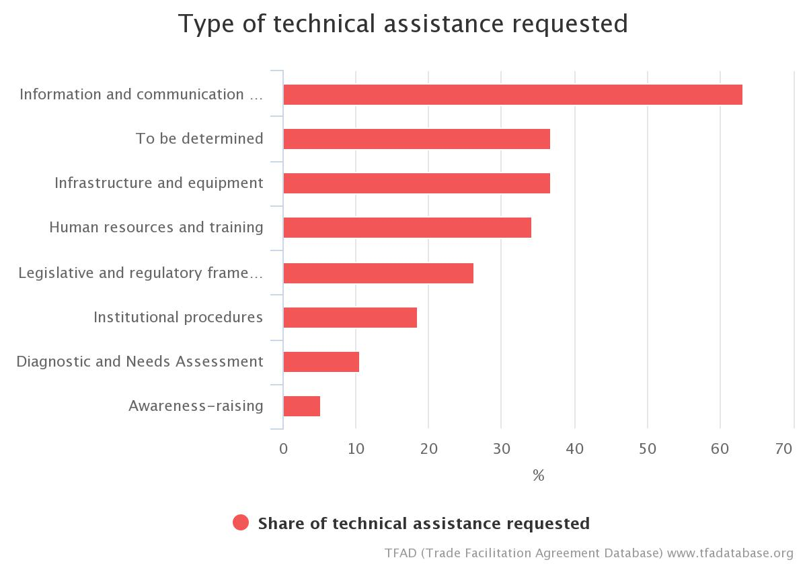

Article 1.3 Chart

Article 1: Publication and Availability of Information

4. Notification
Quick Summary Notes
What activity does this measure regulate?
Communications to/from the WTO Committee on Trade Facilitation.
Which authorities are directly concerned?
- The government authority responsible for WTO notifications (e.g., the trade authority or foreign affairs ministry).
What are the new requirements?
- A Member shall provide the Committee with the names of the official publications and the address(es) of the website(s) where the information required by Article 1.1 and 1.2 has been published.
- A Member shall provide the Committee with the contact details of its enquiry point(s).

Examples of TACB from Member Notifications: GRENADA
- Legal/Policy: Technical expertise to develop user friendly publications.
- Human Resources/Training: Training of relevant border agencies ensuring their understanding of their individual roles and responsibilities in trade facilitation. Training will aid in the identification of appropriate materials for publication by agencies.
- ICT: To develop user friendly websites where information could be easily obtained and accessed.

Examples of TACB from Member Notifications: TRINIDAD AND TOBAGO
- Human Resource/Training – Conduct awareness sessions on procedures for notifications and information to be notified.

Examples of TACB from Member Notifications: SRI LANKA
For Creation of an electronic single information management platform encompassing Official locations where in which the information has been published, Uniform resource locators of website of the TIP, enquiry points responsible for servicing enquires, enabling expeditious & accurate flow of notifications.

Examples of TACB from Member Notifications: MONTENEGRO
Assistance and support for trainings and capacity building for the preparation of notifications in accordance with the WTO rules.

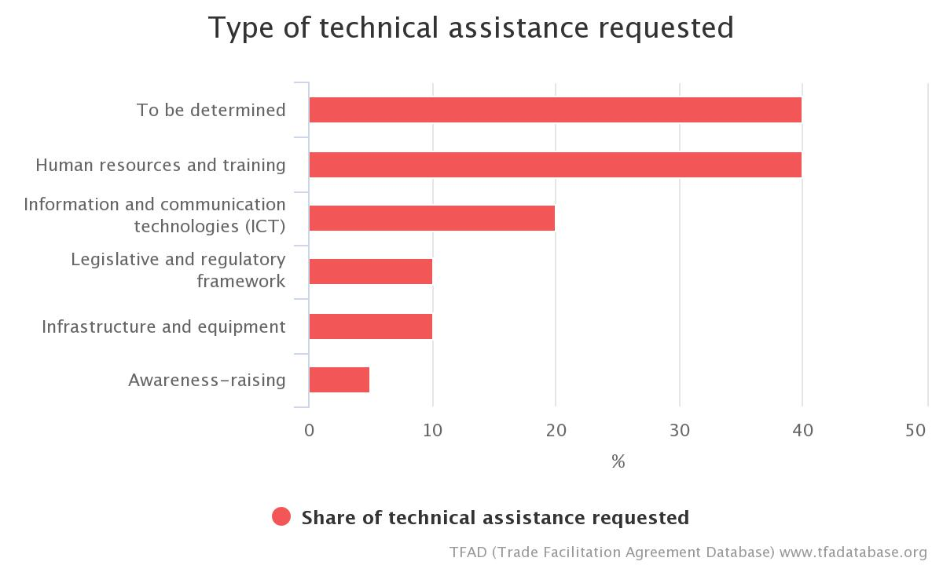
Article 1.4 Chart

Article 2: Opportunity to Comment, Information before Entry into Force and Consultations

Opportunity to Comment and Information before Entry into Force
Quick Summary Notes
What activity does this measure regulate?
The process by which national trade legislation is made. This includes the process for enacting laws on trade-related matters by the national legislative body (congress, parliament, legislature, etc.) as well as secondary legal acts (regulations, rules, orders, etc.) issued by executive or administrative bodies.
Which authorities are directly concerned?
- All border agencies
- Trade Authority
- Executive Authority
- Legislative Authority
What are the new requirements?
- Traders and other interested parties must be given an opportunity and reasonable time to comment on proposals for new trade-related and customs laws and administrative regulations, as well as any amendments thereto.
- New or amended laws and regulations must be made publicly available, as early as possible before their entry into force.

Examples of TACB from Member Notifications: BELIZE
- Provide more links through other trade related websites where all traders can have access to proposed changes to laws and regulations.
- Legal aid/advice required to:
  - Revise/Amend or Repeal the existing laws to take into considerations publication of procedures/administration etc. as prescribed under the AILP.
  - To proceed with compliance to the AILP.
- Training on NTBs/WTO AILP

Examples of TACB from Member Notifications: SAINT VINCENT AND THE GRENADINES
- Assistance to update the legal and regulatory framework to include legal provisions for the stakeholders to comment on new or amended laws and regulation.

Examples of TACB from Member Notifications: TONGA
- Support to establish a consultation mechanism and provide with legal basis e.g. legislation

Examples of TACB from Member Notifications: TRINIDAD AND TOBAGO
- Policy - Develop policy to allow traders and other interested parties to comment on new and amended laws
- Legal - Legislative and institutional amendments (legal consultancy).

Examples of TACB from Member Notifications: PARAGUAY
- Engagement of an independent consultancy firm for the development of a unified approval protocol for the introduction of new measures, timely publication and entry into force, with private-sector participation.

Examples of TACB from Member Notifications: HONDURAS
Technical and financial assistance for:
- Provision of an expert to conduct a diagnosis of the existing domestic and regional regulations and to share best practices and capacity building with the agencies involved;
- Preparation of regulations to enable implementation of this provision;
- Preparation of implementation procedures for all the agencies involved;
- Sharing and dissemination of these new provisions;
- Training of relevant human resources in government agencies.

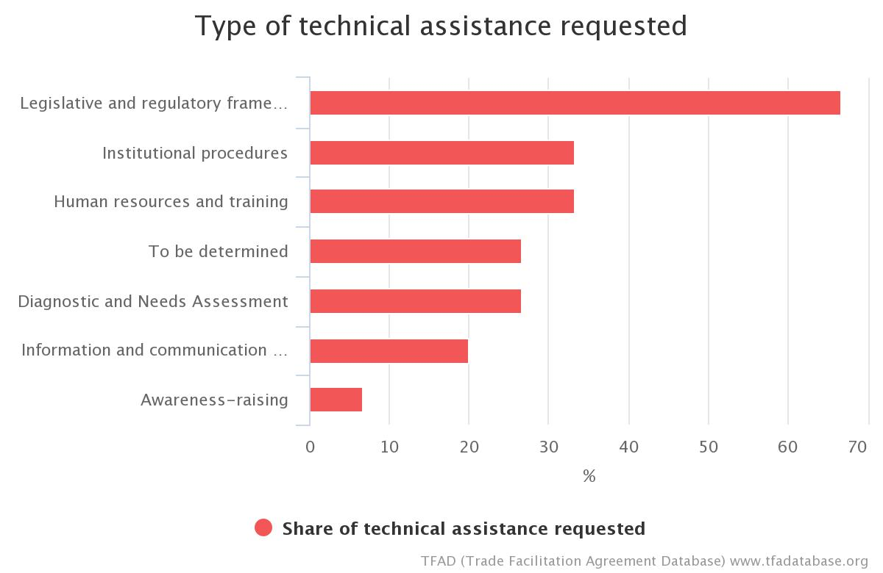
Article 2.1 Chart

Article 2: Opportunity to Comment, Information before Entry into Force and Consultations

2. Consultations
Quick Summary Notes
What activity does this measure regulate?
The process by which border agencies obtain the views of traders and other stakeholders on matters affecting them
Which authorities are directly concerned?
- All border agencies
What are the new requirements?
Border agencies must hold "regular consultations" with traders and stakeholders

Examples of TACB from Member Notifications: BELIZE
- Technical Assistance to develop a Consultation policy; specific areas should include developing skills in regulatory impact assessment.
- Technical Consultancy to develop the strategy/ policy for consultations and designate unit for implementation.
- Legal Counsel to determine a standardized approach to consultations.

Examples of TACB from Member Notifications: SAINT VINCENT AND THE GRENADINES
- Assistance to establish a legal framework for the exchange of information, sharing of control functions amongst agencies.

Examples of TACB from Member Notifications: BAHRAIN
- Technical assistance and support for changing/adapting legal framework in order to introduce and define procedures for consultations.

Examples of TACB from Member Notifications: HONDURAS
- Provision of an expert to conduct a diagnosis of the existing domestic and regional regulations and to share best practices and capacity building with the agencies involved;
- Preparation of regulations to enable implementation of this provision;
- Preparation of implementation procedures for all the agencies involved;
- Sharing and dissemination of these new provisions;
- Training of relevant human resources in government agencies.

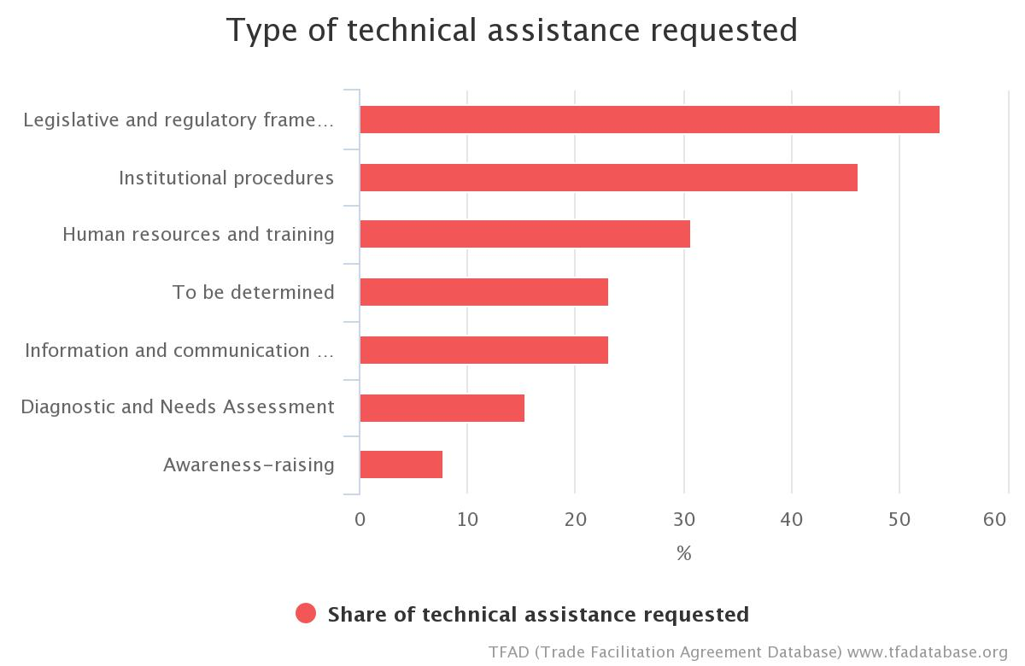
Article 2.2 Chart

Article 3: Advance Rulings
Quick Summary Notes
What activity does this measure regulate?
The means by which a trader can obtain reliable "binding" information about the tariff classification, origin, or other customs treatment of his goods before he imports them
What authorities are directly concerned?
- Customs
What are the new requirements?
- Customs shall provide a written ruling on request of a trader concerning the tariff classification or origin of his goods (or any other matters described in paragraph 9(b) prior to their importation)
- The ruling shall be binding on Customs and remain valid for a reasonable period of time
- A trader shall have rights to be notified if Customs takes certain actions adverse to his interests (such as a refusal to issue a ruling or a decision to revoke or modify a ruling)
- Customs must publish certain information about the ruling process

Examples of TACB from Member Notifications: BELIZE
- Draftsperson needed with expertise in British common law to establish binding rulings.
- Training in binding rulings.
- Train the trainer' program

Examples of TACB from Member Notifications: DOMINCA
- Technical Assistance to draft Legislation to lay the legal platform for a National Ruling Processing Unit in Dominica.
Examples of TACB from Member Notifications: GRENADA
- Legal/Policy: Technical assistance to develop legislation and policies to effectively administer and implement advance rulings.
- Procedures: Technical assistance to develop specific and clear guidelines on procedures to implement and undertake advance rulings.
- Human Resource/Training: Training of Customs Staff, Brokers and Importers on the procedures for advance ruling and its importance as well as how it will be implemented.
- Training in Tariff Classification, Rules of Origin and Valuation for Customs Officers.
- ICT: Technical Assistance to integrate advance ruling into customs automated systems.

Examples of TACB from Member Notifications: GUYANA
- Technical Assistance required: Training staff and adoption of international best practices as increased institutional capacity in classification and valuation will be needed.

Examples of TACB from Member Notifications: JAMAICA
- Train personnel and implement and a "Train the trainer" program;
- Provide ICT infrastructure;
- Develop public education campaigns for stakeholder engagement.

Examples of TACB from Member Notifications: SAINT LUCIA
- Legal drafter for the establishment of a legal or administrative document that addresses this measure.
- Technical assistance to develop and administer the system.
Examples of TACB from Member Notifications: SAINT VINCENT AND THE GRENADINES
- Assistance to establish a legal and Regulatory framework.
- Training in Classification, rules of origin and Valuation.

Examples of TACB from Member Notifications: TRINIDAD AND TOBAGO
- Legal/Policy: Legislative Drafting or amendment of all legislation applicable to the issuance of Advanced Rulings
- Human Resources/Training: Train personnel to support the issuance of Advanced Rulings (e.g. Rules of Origin and Classification)
- Procedural: Development of policy procedures in line with requirements of this article.

Examples of TACB from Member Notifications: MALAWI
- There is need for support for training and sensitization, review of regulatory framework, set up of institutional framework etc. to objectively deal with the matter.

Examples of TACB from Member Notifications: BOLIVIA
Cooperation and technical assistance for the implementation of advance rulings, for which it is necessary to:
- acquire knowledge of the procedural framework and guidelines for processing and verifying proper use of advance rulings;
- know the legal and regulatory implications of issuing them;
- draw up regulations, procedures and other instruments for the implementation, period of validity and revocation of advance rulings.

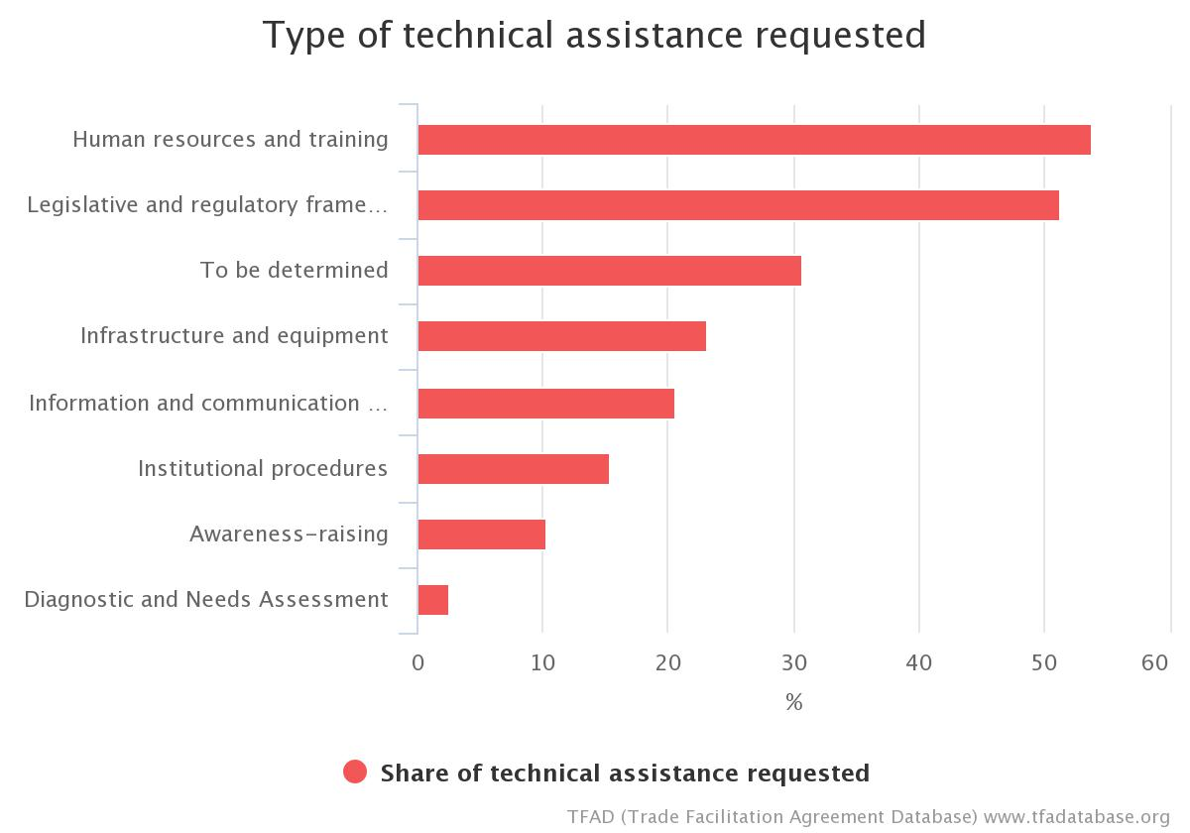
Article 3 Chart

Article 4: Procedures for Appeal or Review
Quick Summary Notes
What activity does this measure regulate?
The rights of traders to obtain review and correction of decisions made by Customs officials or officials of other border agencies
What authorities are directly concerned?
- Customs
What are the new requirements?
Members shall provide traders with the right to appeal decisions made by Customs in an administrative and/or judicial proceeding.

Examples of TACB from Member Notifications: BELIZE
- Consultancy to determine the legal framework for Appeal or Review process.
- Legal Counsel to determine the framework for the institutionalization of the review and appeals process.
- Legal assistance is necessary to develop structure of appeals tribunal.
- Technical Assistance/Guidance to determine the human resource needs.
- Financial and technical resources for equipment and software and expertise in developing an efficient electronic filing system.
- Assistance with developing an appeal policy and relevant procedures.

Examples of TACB from Member Notifications: GRENADA
- Legal/Policy: Technical Assistance to develop policies and procedures to be put in place for effective procedures for appeals or review.
- Procedures: Assistance to develop procedures on appeals and to ensure that these procedures are known/shared with the business community. Technical Assistance to develop Standard Operating Procedures for Customs.
- Human Resource/Training: Technical assistance to develop and build capacity in key stakeholders (border agencies) to have a better understanding of procedures for review and appeal. Training for Appeals Committee Members in customs procedures.
- Infrastructure/Equipment: Office space and equipment to furnish Appeals Committee Office.

Examples of TACB from Member Notifications: JAMAICA
- Train personnel;
- Build a review management system

Examples of TACB from Member Notifications: SAMOA
- Operation: Financial (and technical support where relevant) assistance required for the initial set-up and operation of the Customs Appeal Authority for the first five years.

Examples of TACB from Member Notifications: TRINIDAD AND TOBAGO
- Human Resource/Training – Train personnel
- Legal/Policy - Legislative Drafting

Examples of TACB from Member Notifications: MALAWI
The existing system is not sufficient enough to objectively address the issues. There is need to strengthen appeal and review procedures by:
- support for review and update of legislation; and
- training of specialised Judges, etc.

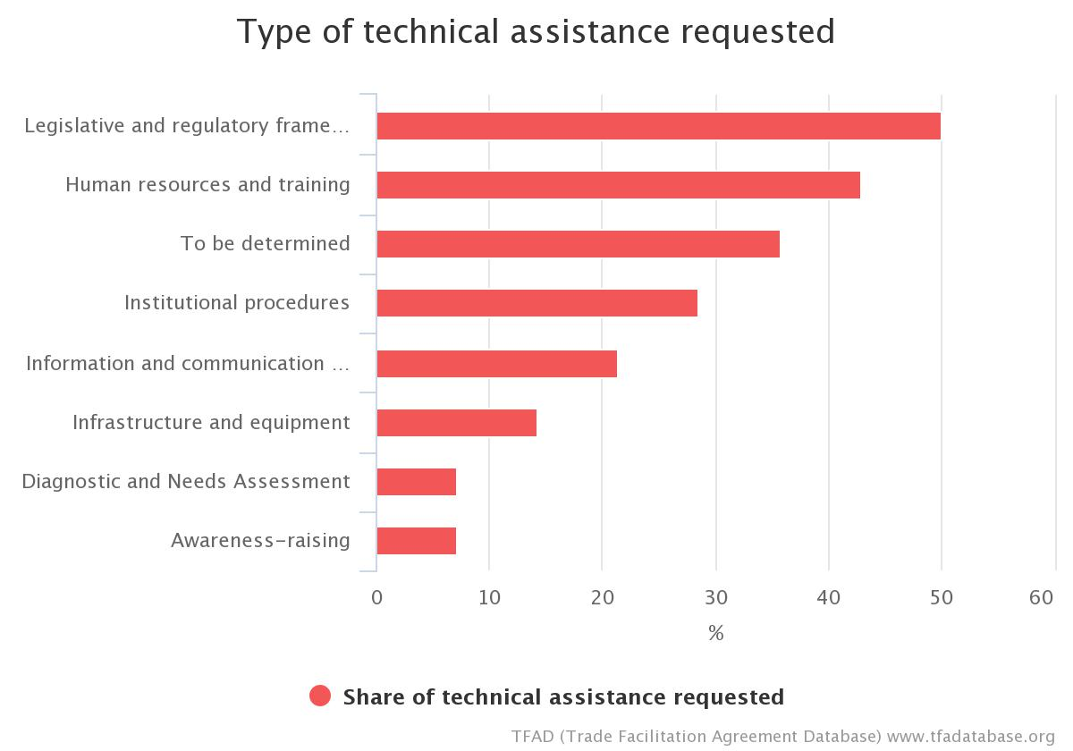
Article 4 Chart

Article 5: Other Measures to Enhance Impartiality, Non-Discrimination and Transparency

1. Notifications for Enhanced Controls or Inspections
Quick Summary Notes
What activity does this measure regulate?
Disciplines on any system of issuing notifications or guidance to concerned authorities to enhance controls and inspections on imported goods, particularly food products, beverages and feedstuffs
What authorities are directly concerned?
- All border agencies
What are the new requirements?
- The conditions under which notifications or guidance may be made and maintained on the system, and the actions taken as a consequence of the notification or guidance, shall be subject to certain disciplines

Examples of TACB from Member Notifications: PAPA NEW GUINEA
- Technical assistance needed to support National Agricultural Quarantine Inspection Authority and Department of Health with:
- Current primary and secondary legislation, and the proposed Biosecurity Bill to be amended to include provisions for a TFA compatible rapid alert system for the notification of a direct or indirect risk to human, animal, or plant life or health deriving from food or feed;
- Build a globally accessible, instantaneous, ICT based communication system for alert and information notifications linking food safety authority, National Agricultural Quarantine Inspection Authority, and border posts (and third countries on the basis of agreements providing for
reciprocity);
- National Agricultural Quarantine Inspection Authority and food safety authority move to strong, scientific evidence-based risk assessment systems to justify enhanced actions as well as to justify removal of enhanced controls.

Examples of TACB from Member Notifications: SAINT LUCIA
- Legal and regulatory assistance: St. Lucia Animal (National & International Movement & Disease Prevention) Act, Plant Protection Act
- Business process analysis: Set up clear areas of responsibility and mechanisms for carrying out related duties and tasks, including confirmatory tests validity across the whole country and process of notification of the component in the exporting country.
- Develop and validate a manual on standard operating procedures on import alert/rapid alert, including a proposal for border agency coordination. Disseminate the manual, if possible through a website, the concerned institutions with a view to clarify their respective interventions.
- Training and capacity building: Provide training and capacity building for confirmatory testing for products that are the potential subjects of alerts and rapid alerts. Organize seminars for agents on the organization of inspection procedures, for technical staff in the areas of laboratory and laboratory management, rules, practices and equipment use according to international standards. Organize also focused seminars for economic operators.

Examples of TACB from Member Notifications: SEYCHELLES
- Funding for infrastructure development, accreditation formalities, procurement of testing& metrology and other laboratory related equipment and consumables;
- Support to build up capacity for testing, inspection and metrology, equipment and training in metrology. Reviewing the legal framework and procedures (SOPs) for analysis of various parameters;
- Technical support to help develop and build capacity of Customs officers and staff of other relevant agencies;
- Technical Assistance and Capacity Building to facilitate notification for enhanced controls or inspections.

Examples of TACB from Member Notifications: TRINIDAD AND TOBAGO
- Legal/Policy - Revision of existing legislation that sets out procedures for enhanced controls or inspections for food, beverages or feedstuffs
Examples of TACB from Member Notifications: NICARAGUA
- Advice on completing notification procedures.
- A section is needed on the IPSA website where the country's sanitary and phytosanitary status can be published, together with IPPC, OIE and WTO information.

Examples of TACB from Member Notifications: MOLDOVA
- Assessment of best practice procedures, development, adoption and publication of border-notification procedures for the purpose of strengthening controls and inspections in line with the proposal, including:
- the criteria according to which a notification may be made;
- the termination or suspension of the alert;
- notifying the importer or the competent authority of the exporting country.
- Staff training in the management of the formal notification system, including national and international best practices;
- Training of relevant border agencies in the field of the operational requirements of the notification system;
- Conduct actions to develop and implement a National Rapid Alert System for Food and Feed (SNARAF) and a National Early Warning Mechanism (MNAT) compatible with those in the EU;
- Strengthen mechanisms for achieving the right to appeal or review by regulating the establishment of Dispute Settlement Boards as a tool to ensure transparency in the administrative procedure for reviewing appeals against actions, inactions of the public agent and against administrative acts issued in control procedures;
- Implement and ensure the functioning of the Dispute Resolution Boards.

Examples of TACB from Member Notifications: HONDURAS
Technical and financial assistance for:
- Preparation of regulations to enable implementation of this provision;
- Preparation of implementation procedures for all the agencies involved;
- Preparation of a manual for quarantine technicians;
- Technical advice for the design and construction of a platform, in the IT systems of the National Agriculture and Food Health and Safety Service (SENASA), the Customs service (DARA) and other relevant government agencies, for blocking goods with a high quarantine risk;
- Software acquisition;
- Provision of an expert to share best practices and capacity building with the agencies involved;
- Human resource training.

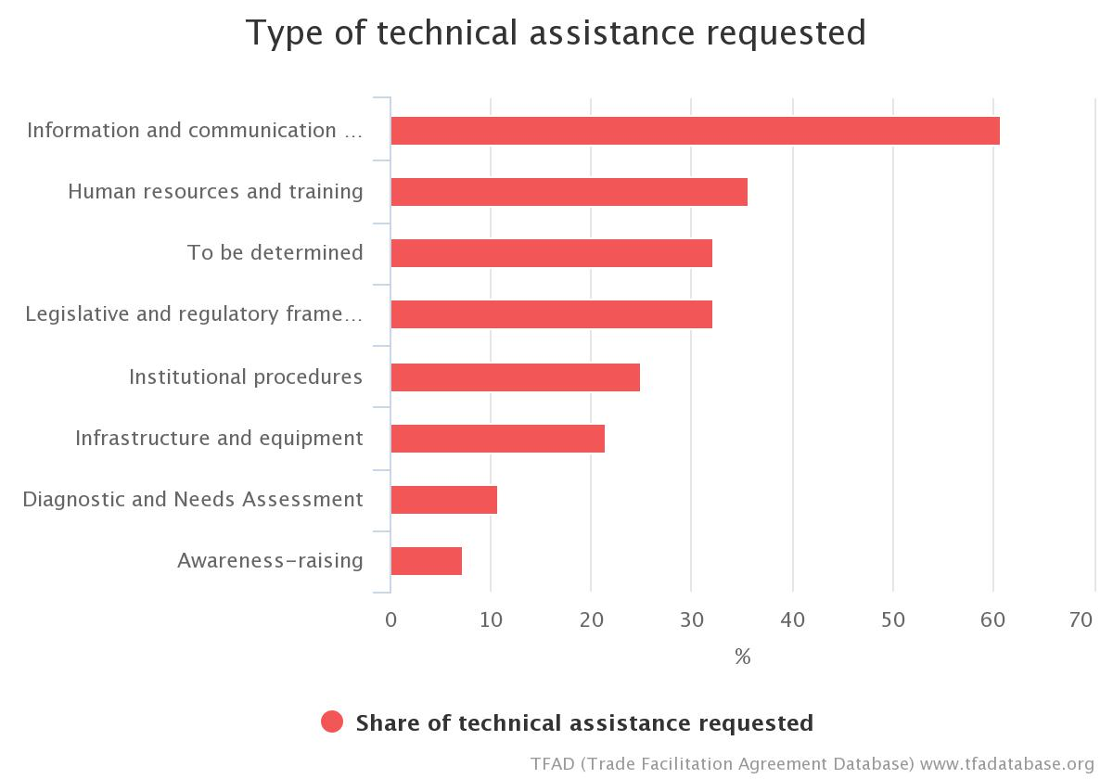
Article 5.1 Chart

Article 5: Other Measures to Enhance Impartiality, Non-Discrimination and Transparency

Detention
Quick Summary Notes
What activity does this measure regulate?
The "detention" of goods declared for importation by Customs or other border authority (e.g., health, safety, agriculture, etc.) for purposes of conducting an inspection
What authorities are directly concerned?
- Customs
- Other Border Agencies
What are the new requirements?
- If Customs or other border authority detains imported goods for inspection, it shall inform promptly the carrier, the importer or his agent (such as the customs broker, acting on the importer’s behalf).

Examples of TACB from Member Notifications: HONDURAS
- Updating and/or adapting the regulations to enable implementation of this provision in respect of quarantine procedures;
- Technical support for the design of an APSS-type web page through which SENASA can provide real-time notification of detentions and their status (transparency);
- Provision of technological infrastructure (ICTs);
- Provision of an expert to share best practices and capacity building with the agencies involved;
- Human resource training.

Examples of TACB from Member Notifications: UKRAINE
- Technical Assistance: advisory support inter alia for design relevant primary and secondary legislation and training on all aspects of this provision.
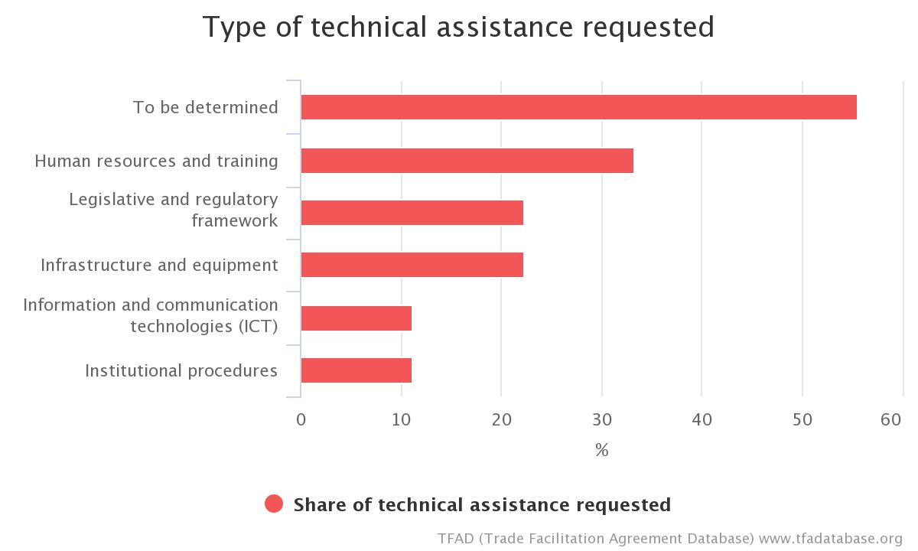
Article 5.2 Chart

Article 5: Other Measures to Enhance Impartiality, Non-Discrimination and Transparency

3. Test Procedures
Quick Summary Notes
What activity does this measure regulate?
Laboratory testing of goods for customs, food safety, agriculture or other regulatory purposes
What authorities are directly concerned?
Border agencies that sample and test goods, such as:
- Customs
- Other border agencies (particularly, SPS and standards authorities)
What are the new requirements?
- Members may grant traders the right to a second test, where test results on a sample of goods taken upon arrival of goods declared for importation are adverse to the trader
- Members shall publish the contact information of laboratories where confirmatory tests can be carried out or provide this information to the importer. (They may be regional or international laboratories, if there are no national accredited laboratories)
- Members shall consider the results of the second test.

Examples of TACB from Member Notifications: BOTWSANA
- Support on Accreditation of Botswana Bureau of Standards testing laboratories
- Review of the Standards Act.
- Training and Capacity Building of BOBS test officers/technicians on method validation and measurement uncertainty.
- Support on maintenance of Accreditation of laboratories.
- Development of the National Quality standards, accreditation and certification.
- Procurement of Testing equipment.
- Development of a new lab including infrastructure and equipment for the Botswana Unified Revenue Services (BURS).
- Specialised software service for the newly developed lab.

Examples of TACB from Member Notifications: FIJI
- Legal/Policy: Develop relevant laws and policies for agencies such as FRCA and Biosecurity Authority of Fiji (BAF) to ensure traders have access to second testing.
- Human Resources/Training: Capacity building for relevant border agencies, laboratory technicians and academic institutions on secondary testing.
- Institutions: Technical assistance and capacity building is needed for academic institutions, public and private laboratories to provide second testing.
- Infrastructure/Equipment: Establishment of accredited laboratory/laboratories to undertake second testing.
Examples of TACB from Member Notifications: GUYANA
- Technical Assistance required: Training staff and adoption of international best practices.
- Development of appropriate legislation to ensure compliance with current standards and coordination with the relevant competent authorities such as the Government Analyst, Food and Drug Department and the Guyana National Standards Bureau.
- Develop in-house testing capability.

Examples of TACB from Member Notifications: JAMAICA
- Technical Assistance and Capacity Building (TACB) supported is required to: Train personnel; Fund the acquisition of equipment.

Examples of TACB from Member Notifications: NIGERIA
- Support on accreditation and maintenance of fully equipped laboratories.
- Training of Laboratory Technicians/Scientists.
- Procurement and installation of High Volume Instrument (HVI) for products classification and grading for premium price.
- Support to ensure collaboration of different regulatory agencies.
- Provision of a platform and support for creation of awareness and information sharing.
- Provision of mobile certified laboratories.
- Training and standards development.

Examples of TACB from Member Notifications: SAINT KITTS AND NEVIS
- Legal/Policy – develop relevant laws and policies for agencies such as Bureau of Standards, Ministry of Health to ensure traders have access to second testing;
- Human Resources/Training – capacity building for relevant border agencies, laboratory technicians and academic institutions on secondary testing;
- Institutions - technical assistance and capacity building is needed for academic institutions, public and private laboratories to provide second testing;
- Infrastructure/Equipment - establishment of accredited laboratory/laboratories to undertake second testing.

Examples of TACB from Member Notifications: SAINT VINCENT AND THE GRENADINES
- Assistance to establish accredited labs, training of laboratory personnel in adequate test procedures.

Examples of TACB from Member Notifications: TRINIDAD AND TOBAGO
- Infrastructure/Equipment – Funding accreditation of local labs
- Human Resources/Training – Train personnel
- Legal/Policy - develop laws and policy to ensure compliance with this article
- Procedures - Development of policy procedures in line with requirements of this article.

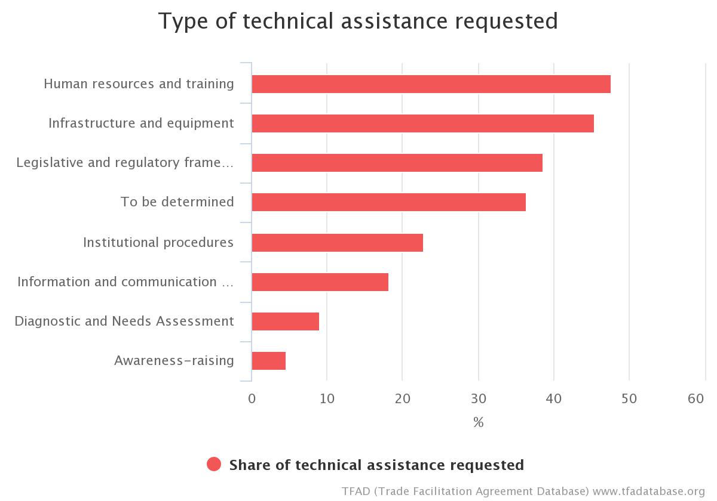
Article 5.3 Chart

Article 6: Disciplines on Fees and Charges Imposed on or in Connection with Importation and Exportation and Penalties

1. General Disciplines on Fees and Charges Imposed on or in Connection with Importation and Exportation
Quick Summary Notes
What activity does this measure regulate?
The "fees and charges" that governmental authorities assess on, or in connection with, imports or exports for services provided to the importer or exporter
What authorities are directly concerned?
- Customs
- Other Border Agencies
What are the new requirements?
- The amount and purposes of any fees or charges imposed on imports or exports must be consistent with the GATT Article VIII restrictions.
- Members must
  - publish specified information about such fees and charges*
  - publish any new or amended fees or charges an "adequate time" prior to their entry into force**
  - periodically review their fees and charges in order to reduce the number and diversity "where practicable"
*You should consider the impact of this requirement in connection your review of Article 1.1 (Publication).
**You should consider the impact of this requirement in connection with your review of Article 2.1 (Opportunity to Comment and Information Before Entry into Force).

Examples of TACB from Member Notifications: BELIZE
- Technical assistance needed for regulatory impact assessment for BAHA. Output would provide the necessary justifications to obtain support for enactment of amended regulations and draft bills.
- Undertake a feasibility study for BAHA.

Examples of TACB from Member Notifications: GRENADA
- Legal/Policy: Assistance to develop policies and laws to aid in the implementation of fees and charges to be applied by customs and other agencies at the borders.
- Procedures: Technical assistance to develop fees structure and how it would be applied to importers and exporters.
- Human Resource/Training: Training of Customs personnel and other agencies in the application of fees and other charges to be applied at the borders.
- Research and analysis: Consultancy to conduct research and analysis into the application of the fees and implementation.

Examples of TACB from Member Notifications: SAINT LUCIA
- Review of the Service Charge Act.

Examples of TACB from Member Notifications: SAINT VINCENT AND THE GRENADINES
- Technical assistance to analyse fees and ascertain cost for each service rendered.
- Drafting guidelines form levying charge.

Examples of TACB from Member Notifications: TRINIDAD AND TOBAGO
- Technical - Procure and fund a consultant to conduct a Time Release Study for Trinidad and Tobago
- Procedural - Develop and publish a single schedule of all fees and charges related to imports and exports.

Examples of TACB from Member Notifications: SRI LANKA
- Expert support on reviewing the current fee structure
- Staff capacity building on periodic review of fees and charges

Examples of TACB from Member Notifications: MONTENEGRO
- Technical assistance and support for defining and introducing the obligation to revise and drafting procedures for a periodical revision of number, diversity and amount of fees so that they reflect the real expense arising from the service rendered;
- Technical assistance and support for mapping of all fees and chargers charged by different agencies that are imposed on/in connection with importation and exportation.

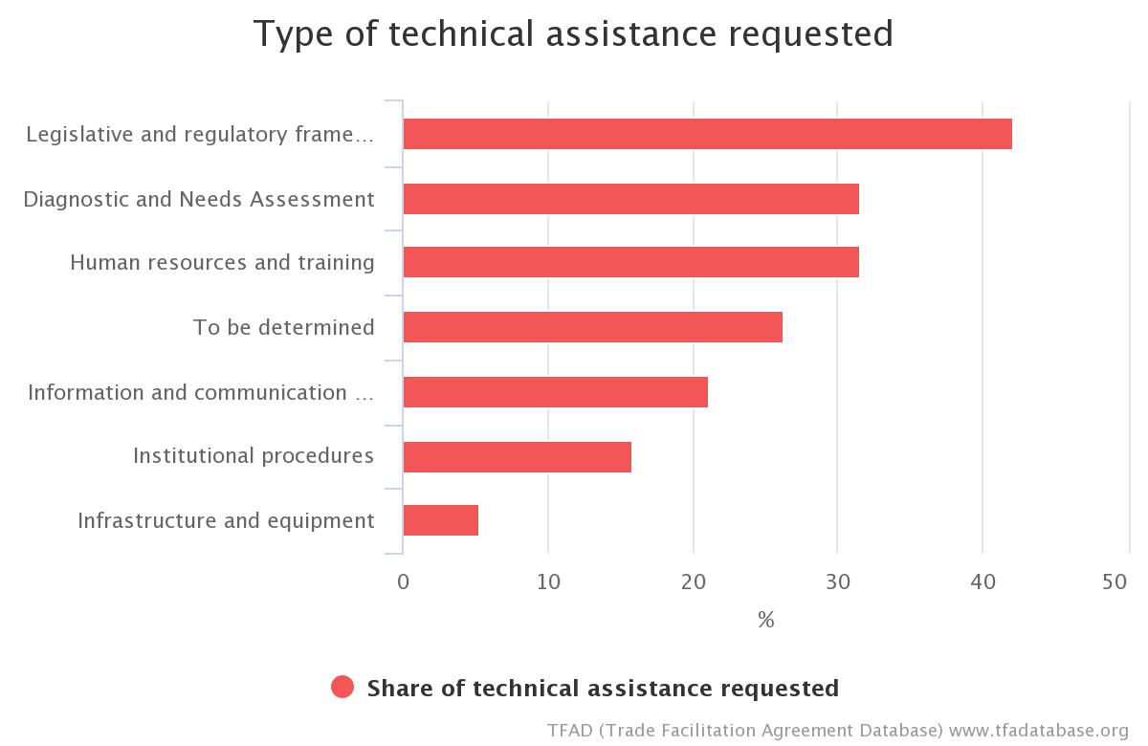
Article 6.1 Chart

Article 6: Disciplines on Fees and Charges Imposed on or in Connection with Importation and Exportation and Penalties

2. Specific Disciplines on Fees and Charges for Customs Processing Imposed on or in Connection with Importation and Exportation
Quick Summary Notes
What activity does this measure regulate?
The "fees and charges" that customs authorities assess on, or in connection with, imports or exports
What authorities are directly concerned?
- Customs
What are the new requirements?
- Customs fees and charges must be limited in amount to the approximate cost of the services rendered.
- Fees not linked to a specific import or export operation must be closely connected to the customs processing of the goods.

Examples of TACB from Member Notifications: DOMINICA
- Technical Assistance for mapping and costing the services rendered by Customs including the development of a fair and transparent Fee Structure.

Examples of TACB from Member Notifications: GRENADA
- Legal/Policy: Assistance to develop policies and laws to aid in the implementation of fees and charges to be applied by customs and other agencies at the borders.
- Procedures: Technical assistance to develop fees structure and how it would be applied to importers and exporters.
- Human Resource/Training: Training of Customs personnel and other agencies in the application of fees and other charges to be applied at the borders.
- Research and analysis: Consultancy to conduct research and analysis into the application of the fees and implementation.
Examples of TACB from Member Notifications: JAMAICA
- Implement efficient system of apportioning costs to ensure that cost appropriation is accurate.

Examples of TACB from Member Notifications: SAINT KITTS AND NEVIS
- Legislative Drafting/Amending of all legislation applicable such as the Financial Act, Customs and Excise Administration Act in order to the application of Customs Service Charge (CSC);
- Procedures – assistance to develop relevant procedures in order to implement and undertake effectively applying CSC.

Examples of TACB from Member Notifications: SAINT LUCIA
- Review of the Service Charge Act.

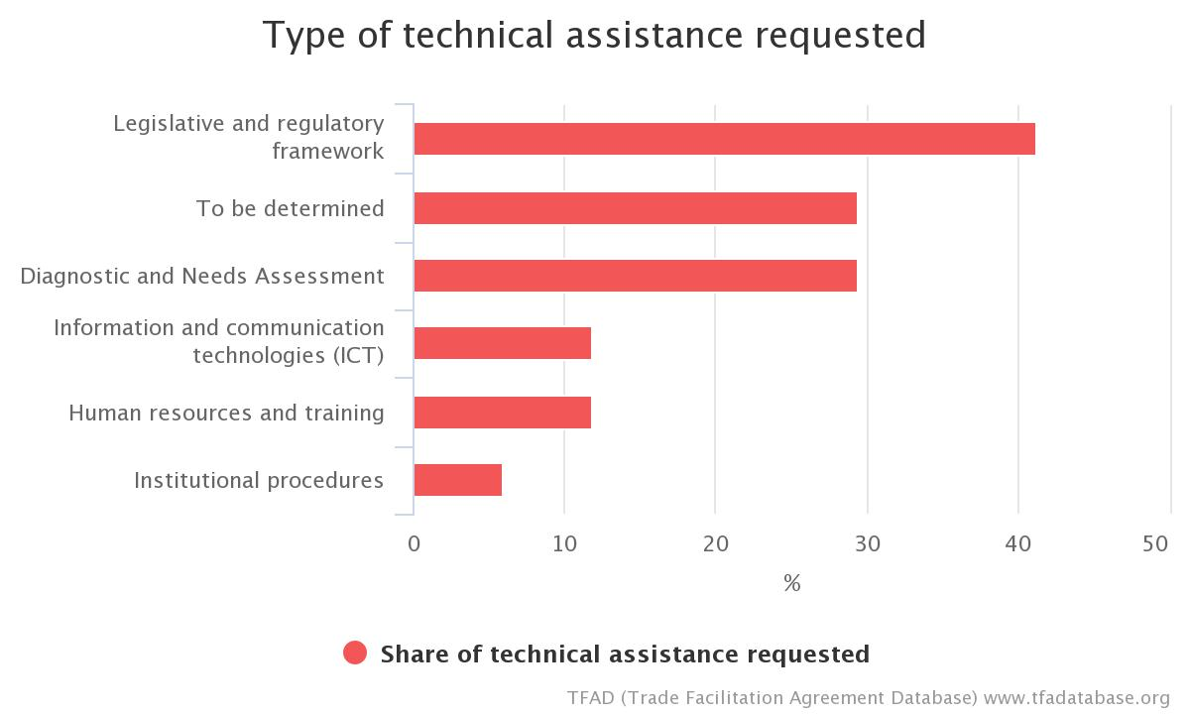
Article 6.2 Chart

Article 6: Disciplines on Fees and Charges Imposed on or in Connection with Importation and Exportation and Penalties

Penalty Disciplines
Quick Summary Notes
What activity does this measure regulate?
The assessment of civil or administrative penalties for violations of the customs laws
What authorities are directly concerned?
- Customs
What are the new requirements?
- Members who apply civil or administrative customs penalties shall:
  - impose penalties only on the person(s) responsible for the violation
  - ensure that the amount of such penalties are proportionate to the degree and severity of the violation
  - avoid conflicts of interest
  - avoid creating an incentive for the assessment of a penalty that is not commensurate with the circumstances of the case
  - provide the person with a written explanation
  - consider a "prior disclosure" as a potential factor to mitigate the penalty amount

Examples of TACB from Member Notifications: JAMAICA
Technical Assistance and Capacity Building TACB supported is required to:
- Review existing legislation;
- Train personnel.

Examples of TACB from Member Notifications: SAMOA
- Capacity building and training for Customs officials on the implementation and application of this provision.

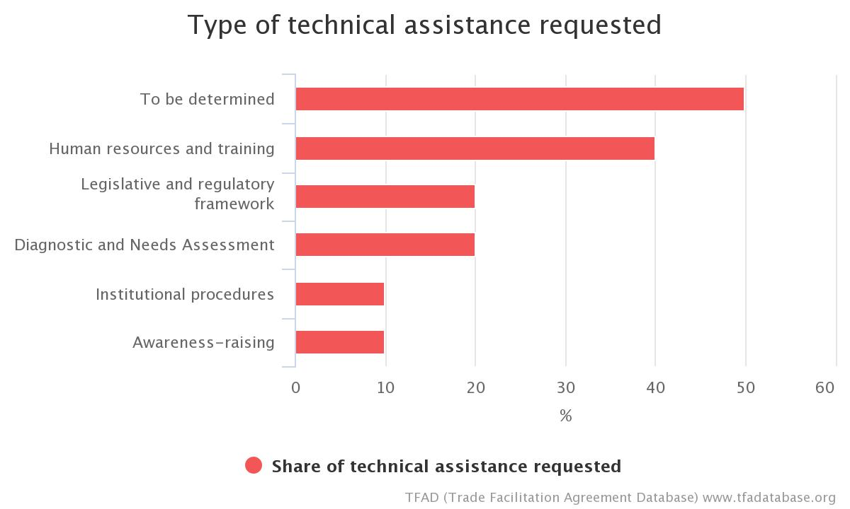
Article 6.3 Chart

Article 7: Release and Clearance of Goods

1. Pre-arrival Processing
Quick Summary Notes
What activity does this measure regulate?
Submission of the documents required for the release of imported goods to customs and other border agencies
What authorities are directly concerned?
- Customs
- Other border agencies
What are the new requirements?
- Traders shall be permitted to submit the import documentation and other information required for release of imported goods, in electronic format where appropriate, prior to arrival of the goods

Examples of TACB from Member Notifications: JAMAICA
- Technical Assistance and Capacity Building (TACB) supported is required to: Acquire additional risk management system.

Examples of TACB from Member Notifications: SAMOA
- Human Resources/Training Capacity building and training for Customs, Quarantine Biosecurity and Border agencies officials on the implementation and application of this provision
- Information and Communication Technology: Enhance the technological capacity of Customs officials in implementing this provision
- Infrastructure: Upgrade existing Customs and Border agencies systems and infrastructure to facilitate Pre-arrival processing
- Upgrade and improvements to existing Quarantine Biosecurity infrastructure to facilitate pre-arrival processing

Examples of TACB from Member Notifications: TRINIDAD AND TOBAGO
- Legal/Policy - Legislative Drafting or amendment of all legislation applicable to this article
- Procedural - Develop and publish procedures.

Examples of TACB from Member Notifications: BANGLADESH
The National Board of Revenue is currently working to implement this Measure with technical assistance from the USAID.
- Support for legislation
- Consultation with stakeholders through workshops, seminars and round table meetings
- Training
- Capacity development

Examples of TACB from Member Notifications: MONGOLIA
- Assistance for capacity building and technical assistance to other authorities than Customs for pre-arrival processing.

Article 7.1 Chart

Article 7: Release and Clearance of Goods

2. Electronic Payment
Quick Summary Notes
What activity does this measure regulate?
The means by which a trader can pay his duties, taxes, fees and charges
What authorities are directly concerned?
- Customs
- Other Border Agencies
- Revenue Authority
What is the new requirement?
To the extent practicable, Members should allow electronic payment of duties, taxes, fees and charges.

Examples of TACB from Member Notifications: SAINT KITTS AND NEVIS
- Legislative Drafting/Amending of all E-legislation and Financial Act in order to undertake Electronic Payment;
- Procedures – assistance to develop relevant procedures in order to implement electronic payment and undertake effectively.

Examples of TACB from Member Notifications: SAMOA
- Legal/Policy: Review existing systems and policies. And determine feasibility and resources required to set-up and operate an electronic payment system
- Human Resources/Training: Capacity building and training for Customs, Quarantine Biosecurity and Border agencies officials on electronic payment
- Information and Communication Technology: Enhance technological capacity of border agencies and government agencies necessary to implement an electronic payment system
- Infrastructure: Development, set-up and installation of appropriate technology and equipment to put in place an electronic payment system

Examples of TACB from Member Notifications: SEYCHELLES
- Seeking the support from UNCTAD for technical assistance and capacity building to incorporate Electronic Payment into the ASYCUDA World and to link it to Seychelles Electronic Funds Transfer (SEFT) which is the new payment platform being developed by the Central Bank of Seychelles (CBS).

Examples of TACB from Member Notifications: TRINIDAD AND TOBAGO
- Legal/Policy - Legislative Drafting or amending of all legislation in order to undertake Electronic Payment
- Equipment - Funding upgrades of the necessary infrastructure
- Human Resources/Training – Train personnel

Examples of TACB from Member Notifications: TOGO
- Preparation of the strategic document for the development of e-payment.
- Development of e-payment solutions (all banks).
- Establishment of technical and financial support measures in digital sectors relating to e-commerce (training, research).
- Enhancement of the GUCE's current functionalities.
- Establishment of e-commerce incubators or start-ups.
- Quality improvement of internet connection.

Examples of TACB from Member Notifications: MAURITANIA
- Assistance in introducing implementing texts from countries that have set up electronic payment systems.
- Planning for changes to Treasury regulations to allow for electronic payment of import and export duties.
- Interfacing of ASYCUDA and the Treasury and banking systems to enable customs to accept credit card payments.
- A study of the three systems to find a standard interface language along the lines of ISO 8583.
- Second interfacing with the future national payments system (RTGS and SWIFT). Payment for the services of an IT firm specialized in interfacing.
- Training of customs and Treasury officers in electronic payments and payment systems.
- Credit card terminals and other necessary infrastructure to be funded for Customs, the Treasury and the banking system (WCO/UNCTAD/EDIFACT).
Article 7.2 Chart
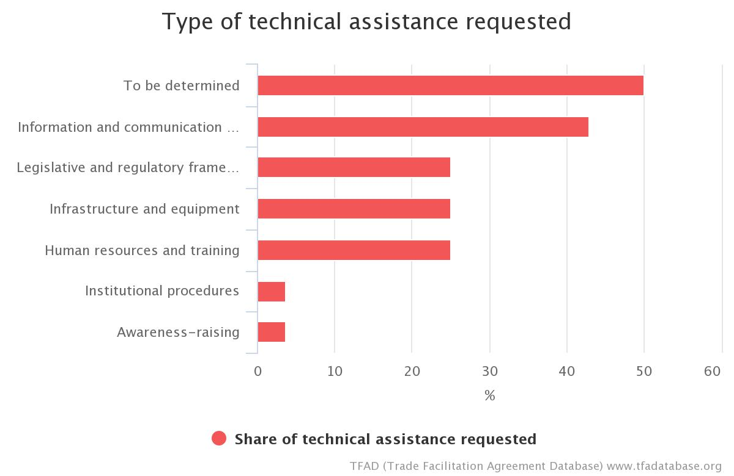

Article 7: Release and Clearance of Goods

3. Separation of Release from Final Determination of Customs Duties, Taxes, Fees and Charges
Quick Summary Notes
What activity does this measure regulate?
Release of imported goods from Customs
What authorities are directly concerned?
- Customs
What are the new requirements?
- Members shall allow importers to obtain release of their goods, under a guarantee, if required, prior to the final determination and payment of customs duties, taxes, fees and charges where the final determination is not done prior to, upon arrival or as rapidly as possible after arrival
- Any required guarantee shall be limited in amount to the equivalent of duties, taxes, fees and charges to which the goods may be liable, as determined by Customs
- If the importer commits an offense, Customs may require a guarantee for the potential fine or penalty as a condition for release of the goods (however, release of goods in cases of violations of law or fraud shall be determined by each Member’s law)
- Customs shall discharge the guarantee without delay when no longer required for its intended purposes/when all requirements have been met

Examples of TACB from Member Notifications: TRINIDAD AND TOBAGO
- Legal/Policy - Development of policy on payment of guarantees for monetary penalties or fines

Examples of TACB from Member Notifications: HONDURAS
- Carrying out a technical/legal diagnosis;
- Preparing the legislation needed to implement this provision;
- Adapting or developing the IT systems of relevant agencies;
- Defining procedures for users and implementing agencies;
- Dissemination and training.

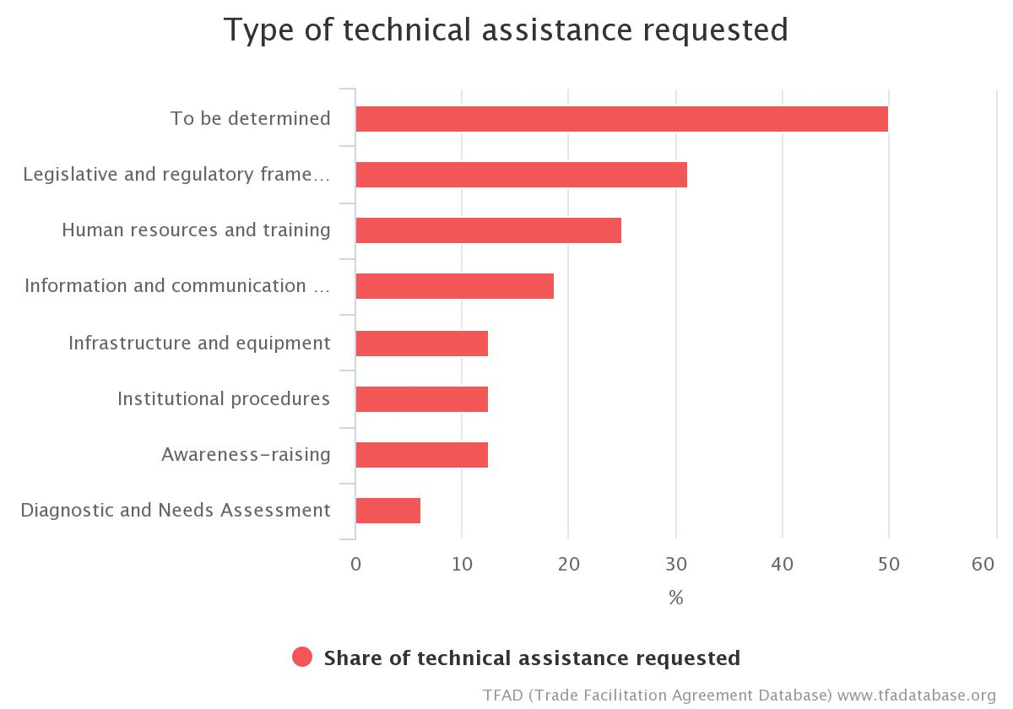
Article 7.3 Chart

Article 7: Release and Clearance of Goods

4. Risk Management
Quick Summary Notes
What activity does this measure regulate?
The methodology or practices that Customs uses to determine which import, export or transit transactions or operators should be subject to control and the type and degree of control to be applied.
What authorities are directly concerned?
- Customs
What are the new requirements?
- Members shall apply risk management to customs control in connection with import, export and transit of goods
- Members shall concentrate customs control on high risk consignments and expedite the release of low-risk goods
- Members shall use appropriate selectivity criteria in applying risk management

Examples of TACB from Member Notifications: BELIZE
- Acquire a legal draftsman.
- Acquire the necessary external technical assistance to develop a risk management strategy.
- Acquire the necessary external technical assistance to establish operating procedures due to lack of standardized criteria.
- Acquire the necessary external technical assistance in areas of risk management analysis in data gathering and criteria building

Examples of TACB from Member Notifications: DOMINICAN REPUBLIC
- Technical and financial support is needed to successfully address all of the risks identified and those that may arise in the process.
- Design a risk management plan to assess and identify the long-, medium- and short-term capacity and infrastructure needed to optimize waiting, loading and unloading times for goods transported to and from our ports.
- Set up comprehensive risk management taking into account all bilateral and global agreements.
- Technical assistance is needed so that all institutions concerned with foreign trade (tariffs, taxes, sanitary and phytosanitary matters, etc.) can have a comprehensive risk management system.
- US$1,000,000 is required to implement this measure.

Examples of TACB from Member Notifications: JAMAICA
- Obtain a comprehensive automated risk management system;
- Source international training to develop a "Train the trainer" program;
- Train personnel.

Examples of TACB from Member Notifications: MAURITIUS
- Technical Assistance required for GAP analysis at MRA, Customs.

Examples of TACB from Member Notifications: PAPA NEW GUINEA
- Technical assistance and capacity building to assist with National Agriculture Quarantine Inspection Authority:
- Existing risk management systems to be revised and made fully applied at operational level eliminating current discriminations due to arbitrary selection of cargo for inspection initially cleared under the green lane;
- A sound compliance management regime needs to be implemented, including with respect to ASYCUDA inspection reporting module;
- For National Agricultural Quarantine Inspection Authority profiling based upon manifest screening to be consistent across PNG, risk-related information need to be centralized, systematically analysed, profile application centralized, etc.;
- National Agricultural Quarantine Inspection Authority profiling must be aligned and ultimately integrated with PNG Customs Services.
- PNG Customs Services requires technical assistance for training on targeting and risk profiling.

Examples of TACB from Member Notifications: SAINT KITTS AND NEVIS
- Legal/Policy – Technical assistance required to develop a mechanism to ensure enhanced coordination and collaboration between border agencies on risk identification and application of risk management;
- Procedures – technical assistance to develop necessary procedures that ensures effective implementation of risk management system;
- Human Resources/Training – technical assistance to develop capacity in relevant border agencies to have a full understanding and application of risk management system;
- ICT – assistance required to acquire as well as enhance technological capabilities necessary to implement a proper risk management process;
- Infrastructure/Equipment – assistance to have relevant technology such as x-ray machines, scanners, laboratory testing facilities in order to implement a proper risk management system.

Examples of TACB from Member Notifications: SAINT LUCIA
- Training is required in both risk assessment and risk management to allow for better risk identification, analysis, assessment and treatment.

Examples of TACB from Member Notifications: SAINT VINCENT AND THE GRENADINES
- Training for customs personnel in identifying risks and assessment analysis.

Examples of TACB from Member Notifications: SAMOA
- Legal: Review/develop legal basis to enhance coordination and collaboration between border agencies on risk identification and application of risk management
- Policy: Develop a risk management policy with target percentages of low/high risk cargo
- Develop a training plan for Customs, Quarantine Biosecurity and Border agencies officials on risk management targeting the application of risk management
- Procedures: Review and develop necessary procedures
- Human Resources/Training: Capacity building and training for Customs and Quarantine Biosecurity officials on risk management using transaction data from ASYCUDA system.
- Training and Development for border agencies staff on risk identification and profiling
- Information and Communication: Technology • Enhance technological capacity of Border agencies necessary to implement a proper risk management process/system
- Infrastructure: Provision of Non-Intrusive Inspection equipment
- Provision of appropriate technology and equipment to support the implementation of a proper risk management system.

Examples of TACB from Member Notifications: SEYCHELLES
- Funding for the procurement of WCO Cargo Targeting System (CTS)which can be integrated with ASYCUDA World;
- Technical support from UNCTAD and WCO to work together on the integration of the system once funding is secured;
- Capacity building to develop a pool of staff to maintain the system once it has been developed.

Examples of TACB from Member Notifications: TONGA
Technical assistance will be needed to develop processes and procedures that incorporate the following in all aspects of risk management:
- Draft a cargo clearance policy and process incorporating a risk based framework and PCA using the RKC as a guide.
- Draft terms of reference for the risk management committee
- Draft position description for staff involved in risk management and set up a risk management unit.
- Train Customs and Quarantine staff on analysing available transaction data from CMS and identifying criteria for high risk cargo.
- Develop risk profiles using available transaction data from CMS.
- Train Customs and Quarantine staff on implementation of a risk based approach in the clearance of cargo.

Examples of TACB from Member Notifications: TRINIDAD AND TOBAGO
- Legal/Policy - Legislative amendments to the Customs Act
- Human Resources/Training – Train personnel in risk management techniques; Periodic training in risk management
- ICT - Acquisition of risk management system software for Customs control; Design and implement Risk Management System
- Procedural - Develop risk registers for importers and other procedures.

Examples of TACB from Member Notifications: TOGO
- Establishment and equipment of the risk management directorate.
- Training of risk management directorate personnel.

Examples of TACB from Member Notifications: BANGLADESH
The National Board of Revenue is currently working to implement this measure with technical assistance from the USAID and the World Bank Group (WBG). Assistance required:
- Support for legislation.
- Consultation.
- Training
- Capacity development
- Need Assessment
The Plant Quarantine Wing has previously received training from the WBG. it requires assistance from development partners for.
- Capacity development of surveillance mechanism.
- Establishment of pest Risk Analysis (PRA) procedure.
- Technical support on risk assessment and mitigation.
- Documentary and awareness development program in social media for moral and ethical responsibilities.
- Preparation of some SOPs and manuals for risk management issues.
The Bangladesh Standards and Testing Institute (BSTI) is working to implement this measure wing technical assistance from the World Bank Group. It requires assistance for:
- Stabilization of the Risk management system following international best practices.
- Training for the Risk Management Committee members.
- On-site visit for Risk Management Committee that have successfully established the system.
No development partner is currently working with Bangladesh Atomic Energy Commission in this regard. It requires assistance from development partners in the area of risk management.
For Developing laboratory facilities, accredited process is going on. plant quarantine wing of DAE need official assistance.
Mentioned that, automation process of import and export permit already been started.

Examples of TACB from Member Notifications: MALAWI
Strengthen Risk Management Unit based on Revised Kyoto Convention and its guidelines. Support for training and mainstreaming of risk management into daily operations.

Examples of TACB from Member Notifications: SRI LANKA
- Legal expert support on drafting legal amendments to existing ordinances/ acts/regulations.
- Expert support on the design and establishment of a risk management system.
- ICT Infrastructure and technology for an automated risk management system.
- Staff capacity building on implementing the risk management system.

Article 7.4 Chart

Article 7: Release and Clearance of Goods

5. Post-Clearance Audit
Quick Summary Notes
What activity does this measure regulate?
Customs verification of compliance with customs and related laws and regulations through examination of the trader’s books and records at his premises following release of the goods
What authorities are directly concerned?
- Customs
What are the new requirements?
- Members must use post-clearance audit "with a view to expediting the release of goods" and, wherever practicable, to inform risk management
- Audits must be transparent and the persons subject to audit should be notified with information about audit results

Examples of TACB from Member Notifications: BELIZE
- Provide specialized training to Post Audit Unit. Secure specialized training from external sources. (WCO, EU and CCLEC).
- Request technical assistance to develop and implement the necessary systems. Secure technical assistance from EU.
- Restructuring of the Post-Audit Unit and acquiring the proper audit software and other analytical tools. Secure technical assistance for training, software and analytical tools funding.

Examples of TACB from Member Notifications: GUYANA
- Resources required include additional staffing with audit skills related to valuation, classification, accounting and procurement of information digitally. Some legislation on the value of digital evidence may be required.
- Technical Assistance is required to: Develop and Publish criteria for Authorised Traders as evolution of "Trusted Trader" Programme.
- Enable electronic filing and processing at land borders which would be dependent upon availability of infrastructure and connectivity.
- Draft Legislation for application of electronic filing and processing.

Examples of TACB from Member Notifications: JAMAICA
- Technical Assistance and Capacity Building (TACB) supported is required to:
  - Develop a comprehensive automated risk management system

Examples of TACB from Member Notifications: SAINT VINCENT AND THE GRENADINES
- Assistance to develop an audit strategy, capacity building for extensive training in auditing for customs and other border agencies.

Examples of TACB from Member Notifications: SAMOA
- Legal: Develop/review relevant legislations and policies for Post Clearance Audit (PCA)
- Policy: Develop a compliance assessment policy and procedure incorporating the connectivity with risk management. Develop a training plan/module to train Customs officials and agents on the concept of 'informed compliance' and train the target groups. Develop a methodology/approach to conduct a national compliance assessment on an annual basis
- Procedures: Develop and update processes and procedures that incorporate these aspects of PCA: Draft a compliance assessment policy and procedure incorporating the connectivity with risk management. Draft a training module to train Customs and the Agents on the concept of 'informed compliance' and train the target groups. Draft a methodology/approach to conduct a compliance assessment on an annual basis for the whole of Samoa. Conduct annual compliance assessments. Train Customs staff to conduct PCA as a compliance assessment tool.
- Human Resources/Training: Capacity building and training for Customs officials to conduct Post Clearance Audit as a compliance assessment tool. Develop data analysis skills and knowledge for Customs and border agencies officials. Capacity building and training for Customs. PCA officials on auditing techniques and methodology.
- Information and Communication Technology: Enhance technological capacity of Border agencies necessary to implement PCA
- Infrastructure: Provision of appropriate technology and equipment to help implement PCA.

Examples of TACB from Member Notifications: SEYCHELLES
- Funding to improve the ASYCUDA World reporting functionality to support Post Clearance Audit (PCA).

Examples of TACB from Member Notifications: TONGA
Technical assistance will be needed to develop processes and procedures that incorporate the following in all aspects of PCA:
- Draft position description for staff involved in PCA and strengthen the PCA unit
- Train Customs and Quarantine staff on analysing available transaction data from CMS and selecting entries/companies for desk audits and field audits
- Train Customs and Quarantine staff on PCA
- Draft and implement an awareness program to educate the trading community on the role of PCA and legislative requirements related to PCA

Examples of TACB from Member Notifications: TRINIDAD AND TOBAGO
- Legal/Policy - Legislative amendments to the Customs Act Legislative and institutional Human resources/Training – Train personnel and develop continuous work programs
- Implement auditing software
- Procedures - creation of a strategic plan in the area of Post Clearance Audit and Risk Management

Examples of TACB from Member Notifications: BANGLADESH
- The National Board of Revenue is currently working in collaboration with the USAID (for transaction-based audit) and the Asian Development Bank (for system-based audit) to become compliant with this Measure.
- Assistance required: Consultation with stakeholders through workshops, seminars and round table meetings; Training; Capacity development

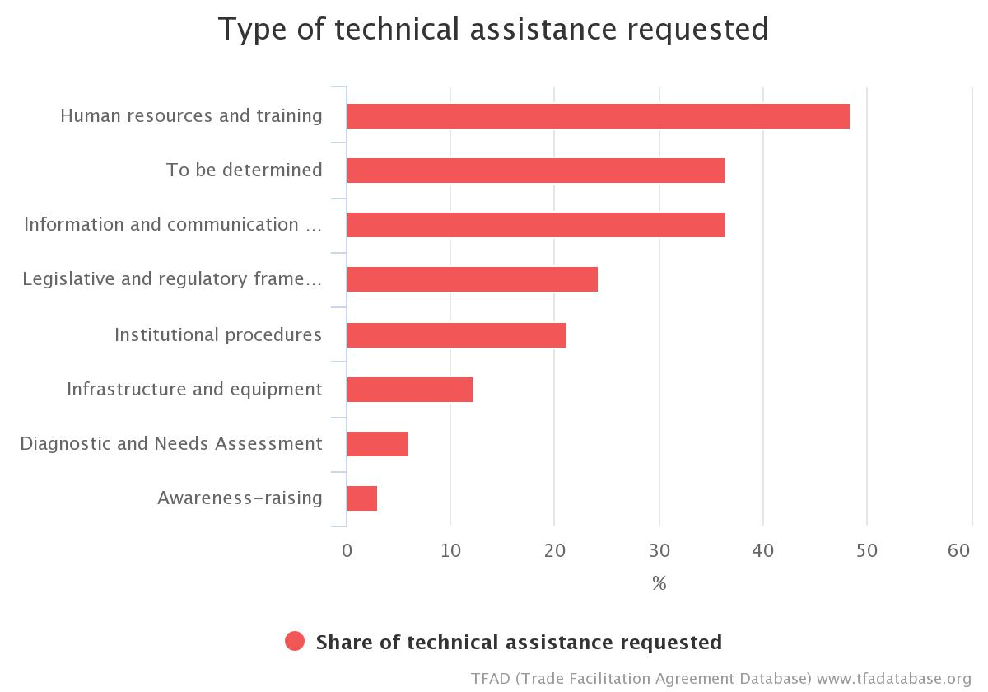
Article 7.5 Chart

Article 7: Release and Clearance of Goods

6. Establishment and Publication of Average Release Times
Quick Summary Notes
What activity does this measure regulate?
Measuring the performance of customs and other border agencies with respect to the release of goods
What authorities are directly concerned?
- Customs
- Other Border Agencies
What are the new requirements?
- Members are encouraged to measure and publish, on a periodic basis and in a consistent manner, the average time it takes to release goods
- Members are encouraged to share their experience in carrying out these measurements with the WTO trade facilitation committee

Examples of TACB from Member Notifications: BELIZE
- Technical assistance to develop TRS policy and procedures.
- Technical assistance for training in the use of TRS software.
- Assistance in conducting a study on the aspects that contribute to average release times for commodities regulated by BAHA.

Examples of TACB from Member Notifications: DOMINICA
- Technical Assistance for preparation of a Guide to measure the average time for release of goods from importation to exit from Port of Entry.
- Training

Examples of TACB from Member Notifications: FIJI
- Procedures: Assistance need to put in place systems to meet TFA requirements to be able to regularly measure and publish average release times.
- Human Resources/Training: Assistance to build capacity within relevant border agency officials to conduct TRS.
- ICT/Equipment: Require assistance to develop and implement automated system to eliminate inaccuracies in the measurement of time taken for processes.

Examples of TACB from Member Notifications: GRENADA
- Policy: Technical assistance to develop policies to implement the publication of average release times in accordance with the TFA.
- Procedures: Assistance to develop procedures to be followed for the regular publication and measurement of the average release times.
- Human Resource/Training: Technical assistance to conduct training of relevant staff within Customs and other border agencies.
- Equipment: Updated computers and software for border agencies compatible with customs automated system.

Examples of TACB from Member Notifications: NIGERIA
- Technical Assistance on use of WCO Time Release Study.
- Sensitization of other border security agencies officials for cooperation during and after the exercise of conducting the Time Release Study.
- Provision of high speed Internet facilities.
- Expert assistance in carrying out tasks by agencies concerns with average release times.
- Provision of many Scanning facilities at the sea.
- Airports to reduce clearing time on goods.
- A release time study is recommended to measure effect of recent reforms on release time.
Examples of TACB from Member Notifications: PAPA NEW GUINEA
- To be undertaken after ASYCUDA World has been fully appropriated and following Technical Assistance for Risk Management and PCA.
- Through Technical Assistance Customs to develop its capacity to conduct Time Release Survey's for measuring the actual performance of its activities as they relate to trade facilitation at the border.
- Technical assistance to be extended to NAQIA subject to deployment of ASYCUDA

Examples of TACB from Member Notifications: SAINT LUCIA
- Development of a legal or administrative document that deals with Average Release Times.
- Review and update the legal/regulatory framework to allow for seamless flow of information and coordination among institutions intervening in border-crossing operations.
- Training and capacity building: Provide training and capacity building to staff/agencies of the concerned agencies and to economic operators on the interpretation of the study results.

Examples of TACB from Member Notifications: TRINIDAD AND TOBAGO
- Legal/Policy - Legislative amendments to the Customs Act
- Technical Assistance - needed to conduct a Time Release Study for Trinidad and Tobago

Examples of TACB from Member Notifications: MALAWI
Capacity building in to enable officials conduct Time Release Studies.

Examples of TACB from Member Notifications: MAURITANIA
- Carrying out of a study on the average release time
- Development of common procedures for determining the release time
- Creation of a committee comprising several agencies to measure the average release time of goods
- Training in designing, planning, conducting and analysing a TRS
- Training on the use of WCO software (WCO)

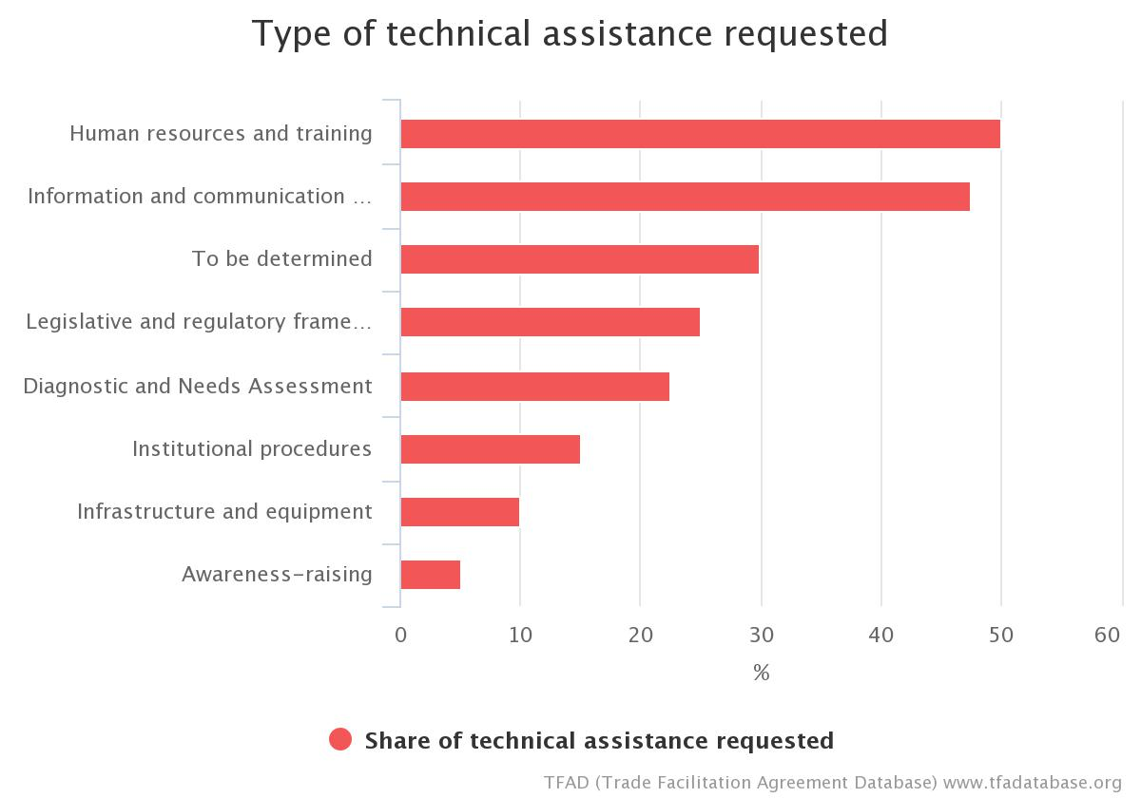
Article 7.6 Chart

Article 7: Release and Clearance of Goods

7. Trade Facilitation Measures for Authorized Operators
Quick Summary Notes
What activity does this measure regulate?
Special or preferential customs treatment provided to reliable traders
What authorities are directly concerned?
- Customs
What are the new requirements?
- Members shall provide certain additional trade facilitation benefits to "authorized operators," or those traders who Customs has determined present a low risk of non-compliance with legal requirements.
- Members shall publish the qualification criteria
- Members’ are encouraged to base authorized trader schemes on international standards, unless inappropriate or ineffective
- A Member shall afford other Members the possibility to negotiate a mutual recognition of their respective authorized trader schemes

Examples of TACB from Member Notifications: FIJI
- Legal/Policy: Assistance required to develop a more open accredited client scheme (which is non-discriminatory e.g. Gold card Scheme) to comply with customs and other related laws and regulations.
- Procedures: Assistance to develop proper procedures with transparent criteria to be applied to assess authorised operators that meet specified criteria in a trusted trade program e.g. Gold card Scheme.
- Human Resources/Training: Capacity building for all border agencies such FRCA and BAF is needed to ensure full compliance with this measure.

Examples of TACB from Member Notifications: GUYANA
- Technical Assistance is required: Training staff and users of the service as it evolves.
- Procure and develop an automated processing system to monitor same. Consideration of integration into ASYCUDA once this is implemented.

Examples of TACB from Member Notifications: PAPA NEW GUINEA
- Technical assistance needed to support: PNG Customs Services: Adopt a policy for the implementation of an AO/AEO scheme based on WCO standards (Revised Kyoto Convention and SAFE Framework of Standards). PNG Customs Services to adopt a compliance assessment program to identify operators with a high level of compliance.

Examples of TACB from Member Notifications: SAINT KITTS AND NEVIS
- Legal/Policy – assistance required to develop a more open accredited client scheme (which is non-discriminatory e.g. Gold card Scheme) to comply with customs and other related laws and regulations;
- Procedures – assistance to develop proper procedures with transparent criteria to be applied to assess authorised operators that meet specified criteria in a trusted trade program e.g. Gold card Scheme;
- Human Resources/Training – capacity building for all border agencies such Customs and Excise Department, Quarantine Department and Port Authority is needed to ensure full compliance with this measure.

Examples of TACB from Member Notifications: SAMOA
- Legal: Develop relevant legislation and policies to allow the setup of an Authorised Operators (AO) program
- Policy: Develop an Authorised Operators policy
- Procedures: Develop proper procedures and criteria for the assessment of authorised operators that meet specified criteria in the AO program.
- Human Resources/Training: Capacity building and training for Customs and Quarantine officials on the implementation of the AO program.

Examples of TACB from Member Notifications: SEYCHELLES
- Technical assistance to draft legislations to provide Customs with the appropriate mandate to afford qualifying traders with additional facilitation in connection with trade;
- Develop a monitoring framework through which Customs can establish and monitor operators' compliance;
- Support for design and implementation of an appropriate system for Authorised Economic Operator;
- Training of Customs Officers and relevant stakeholders to facilitate the establishment and smooth implementation of Authorised Economic Operator.

Examples of TACB from Member Notifications: TRINIDAD AND TOBAGO
- Procedures - Develop an Authorized Operator Programme
- Legal/Policy - assistance with policy development and drafting of regulations Human Resource/Training – capacity building for all border agencies is needed to ensure full compliance with this measure.

Examples of TACB from Member Notifications: TOGO
- Establishment and strengthening of the Privileged Partnership Framework (CPP).
- Private-sector capacity building.
- Training of economic operators.
- Upgrading of operator capacity with a view to the CPP.

Examples of TACB from Member Notifications: CAMBODIA
- TACB is needed for Development of Authorized Operators program including procedures and legislative supports as well as facility.

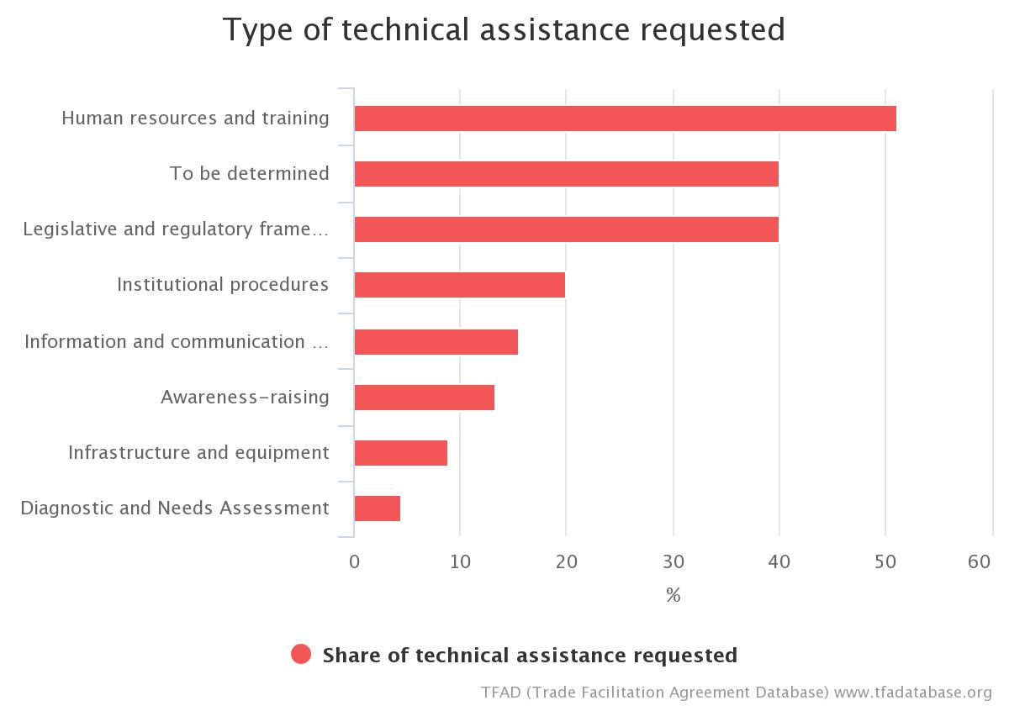
Article 7.7 Chart

Article 7: Release and Clearance of Goods

8. Expedited Shipments
Quick Summary Notes
What activity does this measure regulate?
Documents and goods imported by air express-delivery operators and other expedited shippers
What authorities are directly concerned?
- Customs
- Airport owner/operator
What is the new requirement?
- Members shall establish special facilitative procedures (as described in paragraph 8.2) to allow expedited release of at least those goods entered through air cargo facilities
- Members may permit only those persons or firms who fulfil the criteria listed in subparagraph 8.1 to apply for expedited release treatment
- Criteria for application for expedited release treatment shall be published

Examples of TACB from Member Notifications: SAMOA
- Legal/Policy: Develop relevant legislation and policies
- Procedures: Review of outdated Standard Operating Procedures.
- Human Resources/Training: Training of Customs and Border agencies officials on clearance of commercial cargos at the airports. Training of Customs officials on the implementation of Standard Operating Procedures.
- Infrastructure: Appropriate equipment required such as x-rays, scanners and computers for border agencies.

Examples of TACB from Member Notifications: SEYCHELLES
- Seeking funding and technical support to conduct a feasibility study to assess the possibility of the implementation of the Expedited Shipments.

Examples of TACB from Member Notifications: TRINIDAD AND TOBAGO
- Human Resources/Training - Train personnel;
- Legal/Policy - Legislative amendments to the Customs Act;
- Procedures - Development of procedures for the operation of the programme and provide advice on the criteria to be used to determine companies which qualify.

Examples of TACB from Member Notifications: MONGOLIA
- Support in reviewing the legislation for urgent consignments and to extend it to other selected goods.
- Support for capacity building/coaching of border agencies officers.

Examples of TACB from Member Notifications: KAZAKHSTAN
- Analyse the regulatory framework and develop policies to simplify authorization or licensing procedures, in line with international standards and good practice.
- Train civil servants and customs inspectors and representatives of economic agents in the field of simplified procedures on expedited shipments.
- Develop simplified customs clearance procedures for expedited shipments and ensure the necessary conditions for rapid and qualitative customs controls.

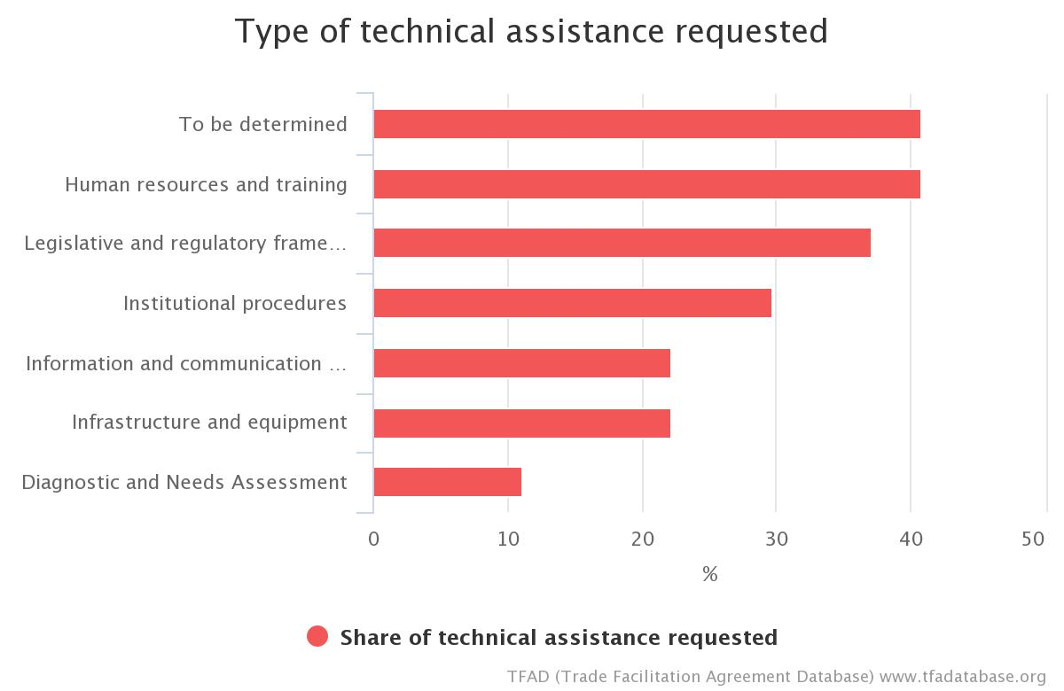
Article 7.8 Chart

Article 7: Release and Clearance of Goods

9. Perishable Goods
Quick Summary Notes
What activity does this measure regulate?
Customs clearance and release of imported "perishable goods"
What authorities are directly concerned?
- Customs
- Other Border Agencies involved in the release of perishable goods
What is the new requirement?
Members shall adopt or maintain procedures for the importation of perishable goods that:
- allow release within shortest possible time;
- provide for release, where appropriate, outside Customs normal business hours;
- give priority to such goods when scheduling examinations;
- allow such goods to be stored in appropriate conditions for their conservation, where facilities approved by the relevant authorities are available;
- where practicable, and upon request, allow release to occur at these storage facilities; and
- require Customs to give a written explanation to the importer, on request, when there is a significant delay in the release of the goods.

Examples of TACB from Member Notifications: DOMINICA
- Legal guidelines for the processing of perishable goods to be developed and implemented.

Examples of TACB from Member Notifications: DOMINICAN REPUBLIC
- Technical and financial support is needed to facilitate the traceability of goods; we also need to create and/or update a mechanism to control and monitor goods from source to final destination.
- Design of an electronic alert and notification system.
- Expert advice on the preparation of a handbook on managing perishables, and development of standards to improve the cold chain for perishable goods.
- Creation of infrastructure, modification of processes, workshops, etc., and quantification of the cost of such projects and programmes.
- Technical assistance is needed so that all institutions concerned with foreign trade (tariffs, taxes, sanitary and phytosanitary matters, etc.) can have a comprehensive risk management system.

Examples of TACB from Member Notifications: GUYANA
- Financial and Technical Assistance is required: Training and development of procedures consistent with best practices. Procurement of tracking software.

Examples of TACB from Member Notifications: SAINT LUCIA
- Review of existing policies, procedures and operations with respect to the management and handling of perishable goods at all ports of entry with a view to updating for the purpose of being aligned with international standards.

Examples of TACB from Member Notifications: MOLDOVA
- Revise and amend, as appropriate, the existing rules on the importation of perishable goods in a way that:
  - Allow release in the shortest possible time;
  - Ensure, as appropriate, release outside the normal working hours of the customs;
  - Give priority to these commodities when planning examinations
  - Allow such goods to be stored under conditions appropriate for their preservation where facilities approved by the relevant authorities are available;
  - If possible and on request, allow release to take place at these storage facilities, and
  - Oblige authorities to provide the importer with a written explanation on request when there is a significant delay in the release of the goods.
- Establishment of official agency agreements, operational guidelines or standards, as appropriate, to ensure co-operation and coordination of border authorities in the process of controlling and releasing perishable goods.
- Simplify procedures for customs declaration and control of perishable goods;
- Elaboration of the Regulation for the transport of perishable and easily altered goods;
- Acquisition of the laboratory to verify the technical parameters necessary for the transport of perishable and easily altered goods and the certification of perishable goods road vehicles;
- Training ANTA collaborators on road freight rules for perishable and easily altered goods and sharing experience with countries that have already implemented these practices;
- Develop training programs for staff involved in perishable freight transport (experts, managers and drivers);
- Establishment of an Information System on the registration of approved transport units for the transport of perishable and easily altered products, as well as access to information on transport units agreed by other states.

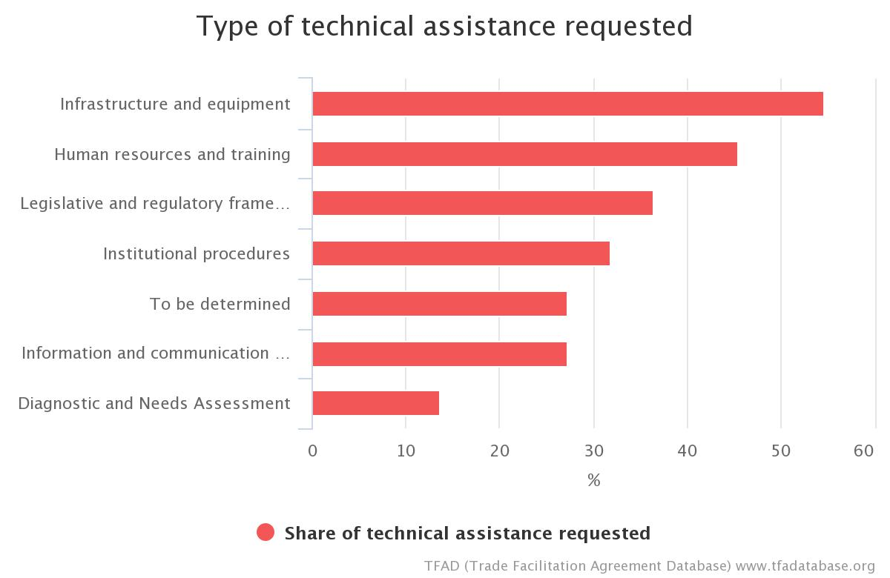
Article 7.9 Chart

Article 8: Border Agency Cooperation
Quick Summary Notes
What activity does this measure regulate?
- The activities of the different national border agencies in connection with an import, export or transit transaction
- The activities of the border agencies of two Members in connection with trade across a shared border
Which authorities are directly concerned?
- All border agencies
What are the new requirements?
- National border authorities/agencies shall cooperate and coordinate border controls and procedures to facilitate trade
- Countries with common land borders shall cooperate and coordinate procedures to facilitate cross-border trade

Examples of TACB from Member Notifications: GUYANA
Article 8.2(b)
- Technical Assistance is required: Enactment of the relevant procedures regulations to guide operations between bordering countries.
Article 8.2(c)
- Financial and Technical Assistance required: Drafting legislation to allow for the acceptance of results of cross border testing and common standards.
- Training and development of testing facilities.
Article 8.2(d)
- Technical Assistance required: Develop IT system to capture all the required information and data at the borders.
Article 8.2(e)
- Financial and Technical Assistance required: Enactment of the relevant procedures regulations to guide operations.
- Increased institutional capacity, infrastructure and equipment.
- Harmonisation of different systems between bordering countries.
- Training for staff of the various regulatory agencies at the border.

Examples of TACB from Member Notifications: PAPA NEW GUINEA
- Technical and capacity building support for: PNG Customs Services and National Agricultural Quarantine Inspection Authority to agree on a Memorandum of Understanding (MOU) including formal procedures of activity coordination in relation to border control;
- Implement agreed processes and procedures, incorporating legislative change if necessary;
- Introduce automation to National Agricultural Quarantine Inspection Authority and an interface with the PNG Customs Services system.

Examples of TACB from Member Notifications: TOGO
- Preparation of texts establishing and organizing joint controls and one-stop border post control.
- Creation of single windows with proper infrastructure facilities.
- Revision of current goods import, export or transit formalities and procedures at border crossings.
- Recruitment of a specialized firm to draw up the harmonized border procedures manual.
- Interconnection of other customs units (customs posts and brigades in the interior) with the customs systems.
- Training in and awareness-raising of new cooperation practices for border agency officials.

Examples of TACB from Member Notifications (Article 8.2 only): CAMBODIA
- TACB is needed to strengthen customs agency’s capacity under the new mandate as a single border agency at the border.
- TACB is needed for pilot project on establishment of single stop inspection.
- TACB is needed for capacity building to all border agencies on Trade Facilitation Agreement.

Examples of TACB from Member Notifications: BANGLADESH
In-country border-agency cooperation:
- The World Bank Group has agreed to provide loan assistance in the area of coordinated border management.
- Plant Quarantine Wing requires assistance from development partners for establishing strong cooperation with all border agencies.
Cross-border agency cooperation:
- No development partner has so far offered any assistance in the area of cross-border agency cooperation. SASEC program under ADB coordinates activities in different South Asian Countries.
Assistance required:
- Negotiation and Consultation
- Capacity development
- Infrastructure
- Automation

Examples of TACB from Member Notifications (for 8.2(d) only): GUATEMALA
Technical assistance is requested to learn about best practices in countries that have introduced joint border controls and gain the necessary experience.

Examples of TACB from Member Notifications: VIETNAM
- Provide necessary infrastructure and facilities for authorities in the border for cooperation toward common internet base.
- Capacity building for officials in the borders to exercises their duty more effectively.

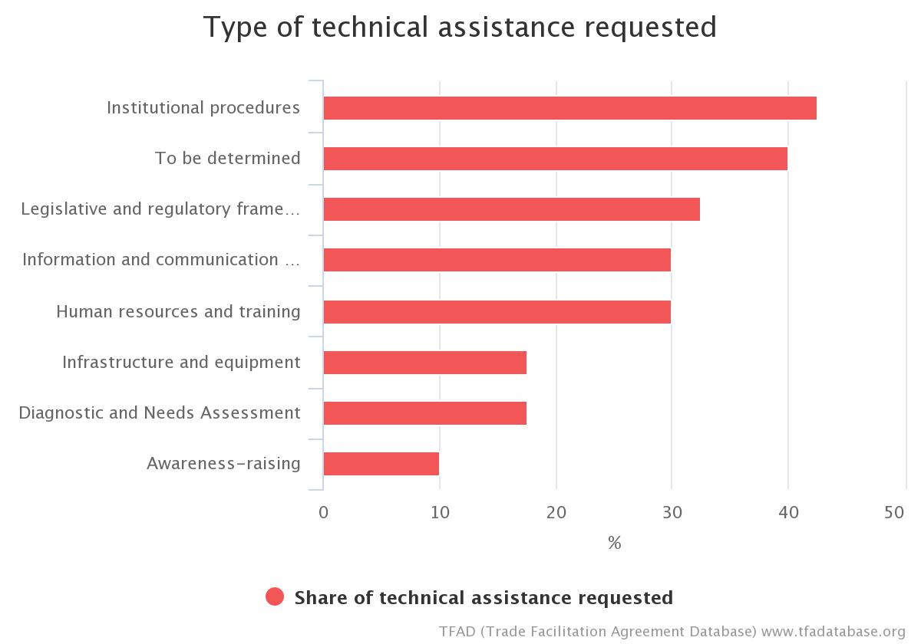
Article 8 Chart

Article 9: Movement of Goods Intended for Import under Customs Control
Quick Summary Notes
What activity does this measure regulate?
Imported goods arrive at one customs office (for example, an international airport or a seaport) for delivery to an inland destination within the same country, where the importer will declare and clear the goods. The goods may be offloaded from the international carrier at the point of entry and loaded on another means of transport (truck or rail, for example) for carriage to the final destination.
The measure is intended to allow the goods to be moved under a simplified procedure to the inland customs office, and permit the importer to clear them at the destination rather than at the port of arrival.
Which authorities are directly concerned?
- Customs
What are the new requirements?
- A declarant should be able to move goods from a customs office of entry to another customs office within the same customs territory.

Examples of TACB from Member Notifications: JAMAICA
- Technical Assistance and Capacity Building (TACB) supported is required to: Review existing legislation and conduct gap analyses.

Examples of TACB from Member Notifications: TRINIDAD AND TOBAGO
- Legal/Policy - Legislative amendments to the Customs Act (legal consultancy) inclusive of regulations and policy.

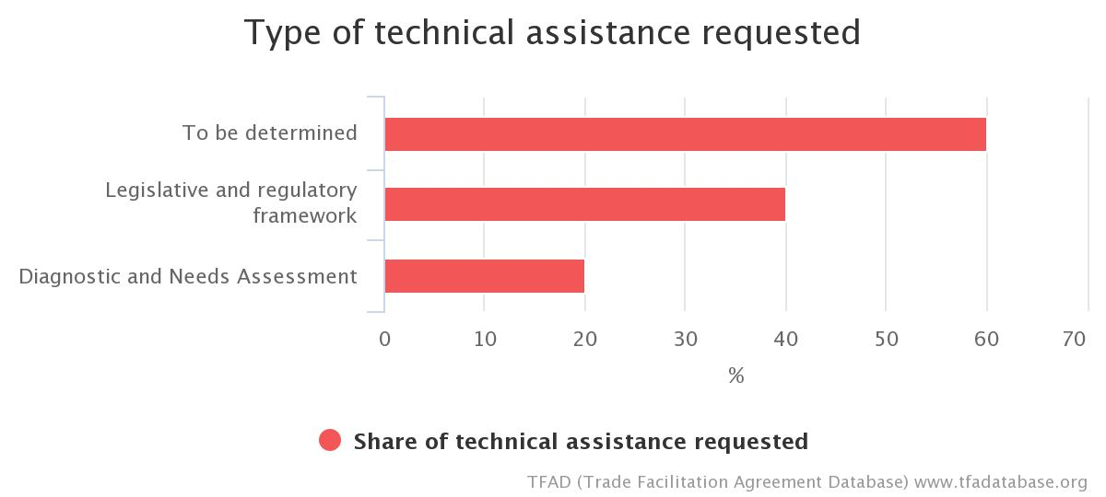
Article 9 Chart

Article 10: Formalities Connected with Importation, Exportation And Transit

1. Formalities and Documentation Requirements
Quick Summary Notes
What activity does this measure regulate?
Import, export and transit formalities and documentation requirements
What authorities are directly concerned?
- All border agencies
What are the new requirements?
- Members must periodically review formalities and documentation requirements with a view towards simplifying or reducing them
- Documentation requirements or formalities should be as fast and efficient as possible. They should not be adopted if a less trade-restrictive solution is available. They should be eliminated or modified if no longer necessary

Examples of TACB from Member Notifications: FIJI
- Legal/Policy: Technical assistance to review relevant laws in order to streamline import and export permits and other necessary requirements.
- Assistance is needed to develop a government-wide strategy to replace all documentation with electronic processing especially in other border related agencies.
- Procedures: Assistance needed to streamline procedures across border agencies to avoid duplication of both procedures and documentation in order to facilitate trade.
- Institutions: Technical assistance needed to promote border coordination as well as assist other agencies to transition to electronic documents.
- Human Resources/Training: Capacity building for relevant border agency Officials to ensure enhanced border coordination.
- ICT: Assistance needed to capacitate other agencies with ICT tools and enablers in order to meet international standards for computerised system as well as expedite clearance.

Examples of TACB from Member Notifications: NIGERIA
- Assistance is needed for the analysis and simplification of document requirements and procedures.
- Analysis of business processes is important.
- Capacity building and training formalities and documentation in line with the international best practices.

Examples of TACB from Member Notifications: PAPA NEW GUINEA
- Technical assistance and capacity building support for: PNG Customs Services and National Agricultural Quarantine Inspection Authority to examine their separate procedures with a view to reducing them and then agree and align their practices and procedures;
- Consider whether legislative amendments will be required and build in the time frame for this accordingly;
- A periodic review process needs to be put in place.

Examples of TACB from Member Notifications: SAINT VINCENT AND THE GRENADINES
- Assistance to identify the necessary administrative and legal arrangements to minimize, reduce and simplify existing formalities and documentation.

Examples of TACB from Member Notifications: SAMOA
- Policy: Support to customs to expedite publication and activation of the new draft procedures under the modernization program
- Information and Communication Technology: Enhance the technological capacity of Customs and border agencies officials to ensure full utilisation of the ASYCUDA World system.
- Infrastructure: Upgrade existing Customs system and infrastructure to implement this provision.
Examples of TACB from Member Notifications: TONGA
- Support to develop policy and legislative framework.

Examples of TACB from Member Notifications: BANGLADESH
- No development partner has so far offered any assistance in the area of perishable goods.
- Assistance required with Training and Capacity development
- Again, Plant Quarantine Wing requires assistance for- (a) the preparation of a valid organogram of Plant Quarantine Authority in Bangladesh, and (b) the establishment of E-Phyto System.

Examples of TACB from Member Notifications: BOLIVIA
- Technical assistance and support to streamline and optimize foreign trade processes and procedures in order to eliminate unnecessary formalities, ensure clear and transparent procedures that meet efficiency targets, incorporate risk management procedures, and are consistent with international standards and international best practice.
- Estimated investment: US$1.25 million.

Examples of TACB from Member Notifications (for 10.1.1 only): COSTA RICA
- Conduct an internal review of the formalities and documentation requirements for drawing up and implementing an improvement plan in conformity with the obligations set forth in the Article.
- Additional Information: Coordination by the Ministry of Foreign Trade and the National Council for Trade Facilitation with the support of the World Bank Group.

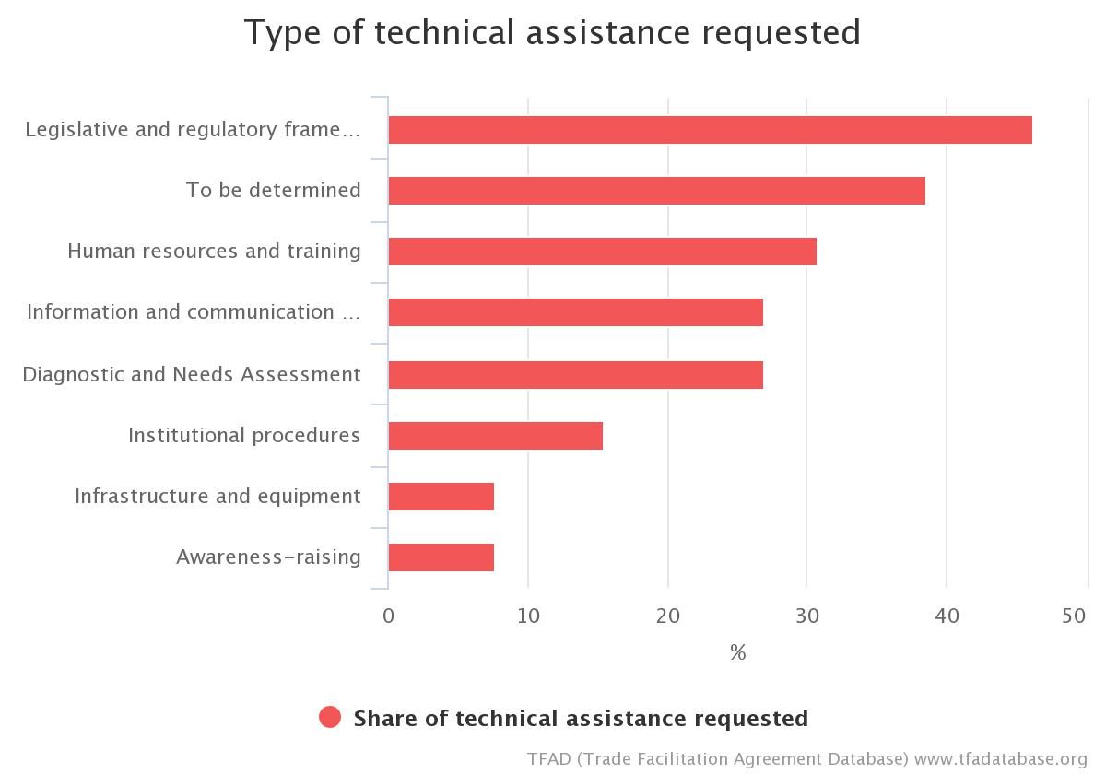
Article 10.1 Chart

Article 10: Formalities Connected With Importation, Exportation And Transit

2. Acceptance of Copies
Quick Summary Notes
What activity does this measure regulate?
Presentation of supporting documents for import, export or transit formalities
What authorities are directly concerned?
- All border agencies
What are the new requirements?
- Border agencies shall endeavour to accept copies of supporting documents that may be required for import, export or transit formalities.
- If the original document has been provided to one government authority, other government authorities shall accept a copy authenticated by the agency holding the original.
- Neither an original nor a copy of the export declaration issued by authorities in the country of export shall be required for importation of the goods.

Examples of TACB from Member Notifications: PAPA NEW GUINEA
- Technical assistance required to support: Amending legislations (incl. Biosecurity Bill) and/or regulations for both PNG Customs Services and National Agricultural Quarantine Inspection Authority allowing acceptance of copies;
- Examining whether systems be developed to allow National Agricultural Quarantine Inspection Authority acceptance of copies there would have to be subordinate legislation changes after Biosecurity Bill is enacted;
- PNG Customs Services to implement ASYCUDA World to take electronic lodgement of supporting documents;
- Reviewing and aligning processes and requirements around documentation and the acceptance of copies.

Examples of TACB from Member Notifications: SAINT LUCIA
- Conduct a Diagnostic Assessment of the existence and usage of policies and legislations with regards to Acceptance of Copies across all border and regulatory agencies with a view to updating and developing the appropriate instrument in keeping with international standards.

Examples of TACB from Member Notifications: TONGA
- Support to develop policy and legislative framework

Examples of TACB from Member Notifications: HONDURAS
Technical and financial assistance for:
- Preparing regulations within domestic legislation to enable the implementation of this measure;
- Adaptation of the IT systems of the relevant government agencies;
- Implementation of a software tool for the digitization and storage of customs and other government agency documents, as necessary;
- Capacity building for implementation and effective follow-up of the measure.

Examples of TACB from Member Notifications: SRI LANKA
- Legal expert support on drafting legal amendments to existing ordinances/ acts/regulations.
- Expert support on developing a system for periodic review of formalities and documentation requirements.
- ICT infrastructure & technology (to be covered through NSW).
- Capacity building support to staff on the benefits of electronic documentation and processes.

Examples of TACB from Member Notifications: (for 10.2.1 only) EL SALVADOR
Technical and financial assistance for:
- Learning about best practices applied by other countries.
- Carrying out a technical and/or legal assessment.
- Drafting a proposal to incorporate the implementation of this measure into the domestic legal framework.
- Conducting an assessment of border agencies in order to determine their capacity to implement software that allows for the digital storage of documents used in import, export and transit operations involving goods.
- Adapting computer systems in order to implement the measure.
- Purchasing computer equipment.
- Training and awareness-raising in the private sector.

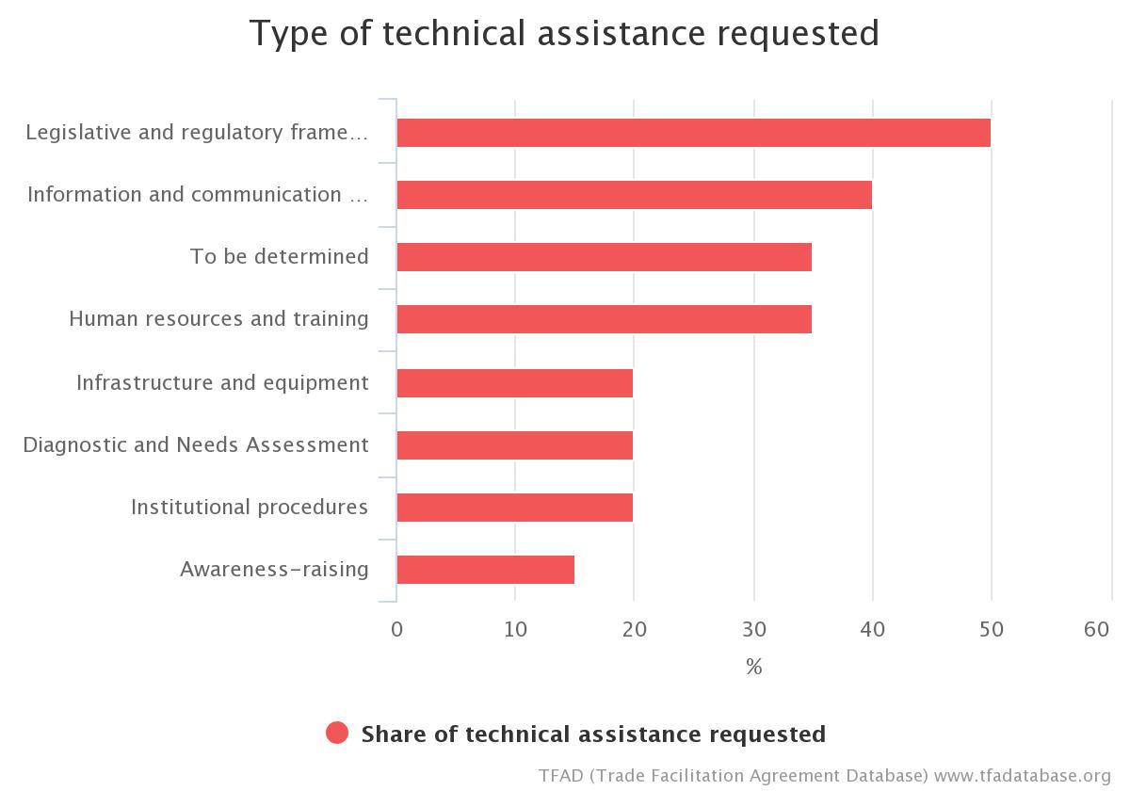
Article 10.2 Chart

Article 10: Formalities Connected With Importation, Exportation And Transit

3. Use of International Standards
Quick Summary Notes
What authorities are directly concerned?
- All border agencies
What activity does this measure regulate?
Import, export and transit formalities, procedures and data/documentation requirements
What is the new requirement?
- Members are encouraged to use "relevant international standards" as the basis for their import, export and transit formalities and procedures.
- Members are encouraged to take part in preparation and periodic review of standards through the "appropriate" international organizations.

Examples of TACB from Member Notifications: BELIZE
- Financial support to participate in meetings of the International Standard Setting Bodies and the WTO/SPS Committee Meetings.

Examples of TACB from Member Notifications: JAMAICA
- Technical Assistance and Capacity Building (TACB) supported is required to:
- Fund participating in overseas training;
- Organize training in change management tools for senior managers;
- Assess the testing, certification, inspection and accreditation capabilities of food safety regulatory agencies and provide assistance for upgrading facilities and achieving compliance with relevant standards;
- Develop and implement a training and certification program to assist exporters to meet relevant standards.

Examples of TACB from Member Notifications: NIGERIA
- Provision of IT infrastructure.
- Training and enlightenment of Customs officers on the use of WCO instruments and tools for uniform implementation of the TFA amongst Customs Administration.
- Support to attend Standard setting meetings.
- Manpower development and training of officers on Freight negotiation, Cost reduction methodology, tariff benchmarking and setting of standards, Transport and logistics, and on confirmation of freight rates.
- Specialised and advanced training on forensic examination and investigation at the interdiction ports to enhance operations quick clearance.
- Training on existing international standards and related legal instruments (such as ECOWAS, WCO and ISO standards).
- Support on implementation of regional standard would be useful if based on broader international/global standards.
- Analysis useful for the implementation of international standards.
- Assistance to develop a coherent and consistent national policy in adopting and implementing international standards.

Examples of TACB from Member Notifications: TRINIDAD AND TOBAGO
- Procedures - Assess the testing, certification, inspection and accreditation capabilities of food safety regulatory agencies and provide assistance for upgrading facilities and achieving compliance with relevant standards
- Human Resources/Training - Develop and implement a training and certification program to assist exporters to meet relevant standards awareness session on the importance of the use of international standards.

Examples of TACB from Member Notifications: MONGOLIA
- Assistance to revise the implementation of standards e.g. GASI on SPS.
- Support for capacity building in application of international standards.

Examples of TACB from Member Notifications: ARMENIA
- Capacity building
- Training of Armenian Customs staff
- Changes in legislation
Technical experts mission in order to make gap analysis in the field of International Standards implementation, as well as provide us with further action plan and advise on financial costs expected, as well as assistance in donors seeking if needed.

Examples of TACB from Member Notifications: SRI LANKA
- Legal expert support on drafting legal amendments to existing ordinances/ acts/regulations.
- Capacity building support to staff on the relevant international standards, testing procedures and international best practices.

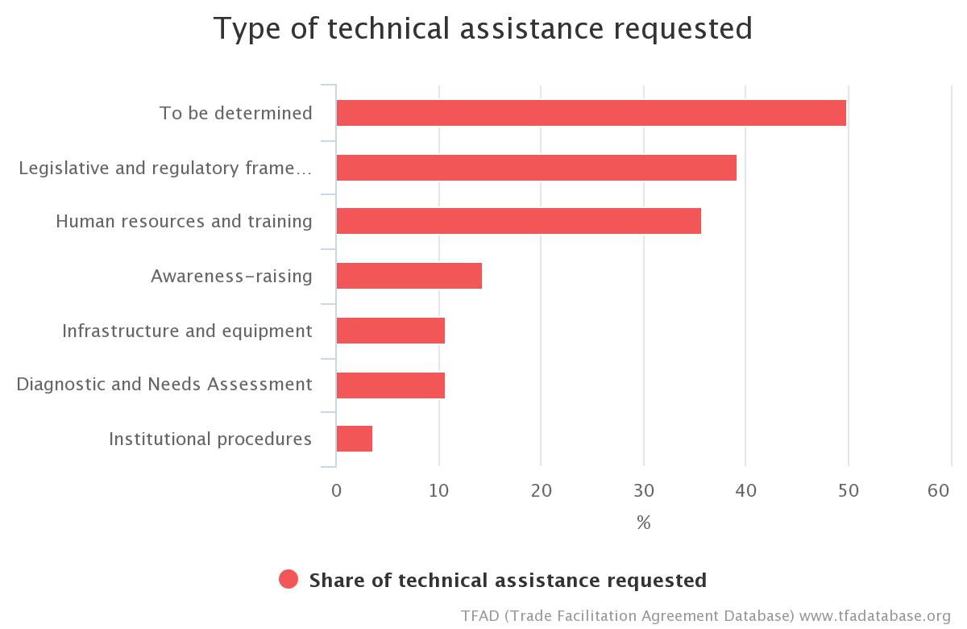
Article 10.3 Chart

Article 10: Formalities Connected With Importation, Exportation And Transit

Single Window
Quick Summary Notes
What activity does this measure regulate?
Traders’ submission of documents/data to multiple government agencies to allow import, export or transit of a goods shipment
What authorities are directly concerned?
- All border agencies
What is the new requirement?
- Members shall endeavour to establish a "single window" to which a trader can submit all documents and/or data required by customs and all other border or licensing authorities for the import, export or transit of goods, and from which the trader will receive all notifications.
- "One-time submission:" where a trader submits required data and/or documents to the single window he/she shall not be asked again for the same information other than in exceptional cases.
- Members shall use ICT to the extent possible and practicable.

Examples of TACB from Member Notifications: BELIZE
- Technical Assistance and training for establishing a Single Window facility required.
- Technical Assistance: equipment for the operation of the single window.
Capacity Building: Training for users (authorities, customs brokers, etc.) of the single window.
- Public awareness campaign on the need and benefits of the single window.
- A regional approach is being taken towards a regional single window; which will be compatible with international standard; Belize taking a national approach in being fully compliant. (Key issue: compatibility).

Examples of TACB from Member Notifications: BOTSWANA
- Conduct Feasibility studies and business cases
- Develop IT platforms for other border agencies
- Training for all Trade Related Ministries

Examples of TACB from Member Notifications: DOMINICA
- Administrative/Operational support to develop a model harmonized common data proposal for relevant Border Agencies including proposal for single payment of all fees.
- With concept paper already developed, financing for database construction and Consultancy Services.
- Technical Assistance to update the Legislative, Institutional and Regulatory framework of relevant Agencies.
- Training for users of the Single Window to include all Border Agencies, Shippers, and Customs Brokers among others.
- Develop a monitoring and evaluation mechanism.
- Sensitization of the Private Sector

Examples of TACB from Member Notifications: DOMINICAN REPUBLIC
- Technical and financial assistance is needed, as well as involvement of the public and private sectors in the recruitment of experts and the procurement of IT and infrastructure.
- The VUE must be linked to several accredited quality control laboratories to guarantee the conformity of products for export.
- The objectives and scope of this tool (Decree No. 626-12) need to be evaluated, adjusted and strengthened to bring it into line with the long-, medium-, and short-term strategies and objectives of this global trade agreement.
- Procurement of technological resources for institutions working with customs authorities and for the logistics community, and re-engineering.
- Implementation of a communication strategy to foster cultural change among staff of institutions concerned with foreign trade.
- Technical assistance is needed so that all institutions concerned with foreign trade (tariffs, taxes, sanitary and phytosanitary matters, etc.) can have a comprehensive risk management system.
- US$10,000,000 is required to implement this measure.

Examples of TACB from Member Notifications: FIJI
- Legal/Policy: Technical assistance to review relevant laws in order to develop comprehensive national single window.
- Technical assistance needed leading to setting a clear time scale of single window role out and implementation.
- Procedures: Development of efficient procedures and checklist in order to implement national single window effectively.
- Institutions: Technical assistance to build capacity in relevant border agencies in order to implement national single window.
- Human Resources/Training: Capacity building needed for relevant border agency Officials and business community to be sensitised, equipped and trained in order to implement national single window.
- ICT: Assistance to ensure reasonable to high level access to IT equipment's especially for other border agencies.
- Infrastructure/Equipment: Assistance required in setting up and installing appropriate IT equipment's and systems in some agencies and at ports of entry.

Examples of TACB from Member Notifications: GRENADA
- Legal/Policy: Technical Assistance to review relevant legislations from different border agencies to develop one single window to be used by all border agencies. Technical Assistance for setting clear time scale for roll out and implementation of Single Window.
- Procedures: Assistance to develop efficient and effective procedures in order to implement national single window.
- Human Resource/Training: Training and capacity building for relevant border agencies. Sensitization of business community in order to implement single window.
Examples of TACB from Member Notifications: GUYANA
- Financial and Technical Assistance required: Procurement of ASYCUDA software and any necessary hardware.
- Training IT staff and users of the new ASYCUDA system.

Examples of TACB from Member Notifications: JAMAICA
- Technical Assistance and Capacity Building (TACB) supported is required to:
  - Procedure consultant to coordinate the development of the policy and legal framework for the single window;
  - Procure consultant to coordinate the development of the policy and legal framework for streamlined procedures;
  - Fund consultant to review procedures;
  - Fund needs assessment for human resources training;
  - Develop curriculum for training programme on Harmonized System (HS) of Tariff Nomenclature and
  - single window operations;
  - Procure hardware and software for single window kiosks;
  - Procure storage area network for database;
  - Procure ICT cabling, fit-out and cabinets.

Examples of TACB from Member Notifications: MAURITIUS
- Acquisition of ICT and other equipment.
- Training and Capacity Building.
- Changing legal and/ or regulatory framework.
- Institutional and Administrative changes.
Examples of TACB from Member Notifications: NIGERIA
- Automation of Customs and other border agencies’ operations.
- Provision of IT infrastructure. Continuous Training of all regulatory agencies' officers
- Assistance on the following: Analysis of business processes; analysis of the legal background; creation of an enabling legal environment; data harmonization and alignment with international standards.
- Creation of a relevant IT system.

Examples of TACB from Member Notifications: PAPA NEW GUINEA
- Technical assistance and capacity building required to:
- Implement the Single Window feasibility study recommendations;
- Replace document manual processing systems with automated systems (all agencies except PNG Customs Services);
- Expedite effective implementation of ASYCUDA World that integrates all border clearance agencies;
- Facilitate all agencies involved in border clearance and regulation of trade to jointly establish a common strategy for the phased implementation of a single window;
- Assist the National Trade Facilitation Committee to decide on which single window model is to be implemented;
- Implement the single window;
- Support the process for enactment of an ecommerce legislation.

Examples of TACB from Member Notifications: SAINT KITTS AND NEVIS
- Legal/Policy - technical assistance to review relevant laws in order to develop comprehensive nation single window;
- Technical assistance needed leading to setting a clear time scale of Single Window role out and implementation;
- Procedures - development of efficient procedures and checklist in order to implement national single window effectively;
- Institutions - technical assistance to build capacity in relevant border agencies in order to implement national single window;
- Human Resources/Training capacity building needed for relevant border agency Officials and business community to be sensitised, equipped and trained in order to implement national single window;
- ICT –assistance to ensure reasonable to high level access to IT equipment's especially for other border agencies;
- Infrastructure/Equipment – assistance required in setting up and installing appropriate IT equipment's and systems in some agencies and at ports of entry.

Examples of TACB from Member Notifications: SAINT LUCIA
- Training and capacity building as well as financial assistance to obtain the necessary IT support.

Examples of TACB from Member Notifications: SAINT VINCENT AND THE GRENADINES
- Assistance to develop a conceptual design for a system to facilitate a single window.
- Technical and financial assistance in procuring ICT equipment.

Examples of TACB from Member Notifications: SAMOA
- Legal: Review/develop relevant laws to facilitate the development of a comprehensive national single window. Compliance review. Develop Memorandum of Understanding (MOUs) with other agencies to enhance cooperation
- Policy: Conduct a feasibility study to explore the viability of a national single window system. Develop a strategy for the implementation of single window.
- Procedures: Develop appropriate procedures and processes to facilitate the implementation of single window
- Human Resources/Training: Capacity building and training for Customs officials and border agencies on the implementation of single window system. Capacity building for other government agencies and private sector on the implementation of single window system
- Information and Communication Technology: Review of national ICT policies to facilitate the implementation of single window. Enhance and upgrade technological capabilities of border agencies and government agencies necessary to implement the single window
- Infrastructure: Provision of appropriate technology and equipment to help implement single window.

Examples of TACB from Member Notifications: SEYCHELLES
- Drafting of legislation, policy framework, strategy and TOR;
- Conduct Feasibility study for AW based Single Window;
- Design, implementation and operation of single window;
- Training of all stakeholders;
- Funding to acquire the relevant equipment and software;
- Implementation of the integrated IT infrastructure which will connect to the existing system/ or activate the
- ASYCUDA SINGLE WINDOW MODULE.

Examples of TACB from Member Notifications: TONGA
- Support to for a feasibility study to investigate viability of a Single Window system and based on results further support to implement - if viable.

Examples of TACB from Member Notifications: TRINIDAD AND TOBAGO
- Technical - Develop information security plan, Business Continuity System;
- Develop change management strategy;
- Develop capacity building program and knowledge management strategy and Service Oriented Architecture
- Legal/Policy - technical assistance to modernize legislative and institutional framework and institutional governance of the Single Electronic Window
- Procedural - Conduct business process reengineering
- Human Resource/ Training – Train personnel; Undertake public awareness
- campaign
- ICT - Develop a Trade Data Information System, an Integrated Multimodal Logistics Module, Information Security Plan, Business Continuity System and Service Oriented Architecture

Examples of TACB from Member Notifications: CUBA
- Technical assistance required to train the staff needed to set up the single window, particularly with regard simplification processes, and to help transfer the knowledge needed to update the competent national authorities and help them to adapt to the new system. Purchase of information and communication technology equipment as well as other types of equipment. There has been a feasibility study and a project by UNCTAD dating back to August 2014, but there are no donors to help implement them.

Examples of TACB from Member Notifications: CAMBODIA
- TA is required to fully develop and implement the national single window. Currently, Customs has been developing the national single window by completing phase I, which integrate with Ministry of Commerce’s CO system and plan to develop the 2nd phase which links to 5 line ministries in 2019.

Examples of TACB from Member Notifications: BANGLADESH
The National Board of Revenue is currently implementing the project with loan assistance from the World Bank.
Assistance required:
- Support for legislation
- Consultation with stakeholders through workshops, seminars and round table meetings
- Training
- Capacity development
- Coordination mechanism among intra and inter agencies is required
Again, ICT related assistance (both hardware and software) will be required at the ports.
Further, technical assistance for data standard management will be required at BCSIR.

Examples of TACB from Member Notifications: MONTENEGRO
- Assistance and support for raising awareness and understanding on SW concept, different SW models, development phases, financing possibilities, coordination models, best practice examples, etc.;
- Technical assistance and support for preparation of gap and needs analyses of the legal, operational and technical capacities of all authorities concerned;
- Technical assistance and support for preparation of the strategic plan for the development of the chosen SW model as well as defining an operational and governance model for the monitoring and implementation of the SW project;
- Technical assistance and support for changing/adapting legal framework in order to introduce and define procedures to support specific features of SW;
- Technical assistance and support for conducting business process analysis and re-engineering business process model ("as is - to be" model);
- Assistance and support for preparation and implementation of capacity building plan, incl. trainings and recruitment of new staff;
- Technical and financial assistance and support for preparation and implementation of the SW development project (incl. fee model, risk management model, procurement plan);
- Technical, IT and financial assistance and support for creation of an e-platform and acquisition of IT equipment;
- Technical and financial assistance and support for setting up into function Single Window;
- Financial support for the implementation of the "Timestamp issuing system" project - the purchase of the system, its implementation, warranty period and support;
- Other technical and financial assistance and support for implementation of Article 10.4

Examples of TACB from Member Notifications: ALBANIA
- Technical assistance to build capacity in relevant border agencies
- Assistance to ensure high level access to IT equipment to border agencies
- Changing of legal and/or regulatory framework
- Institutional and administrative changes

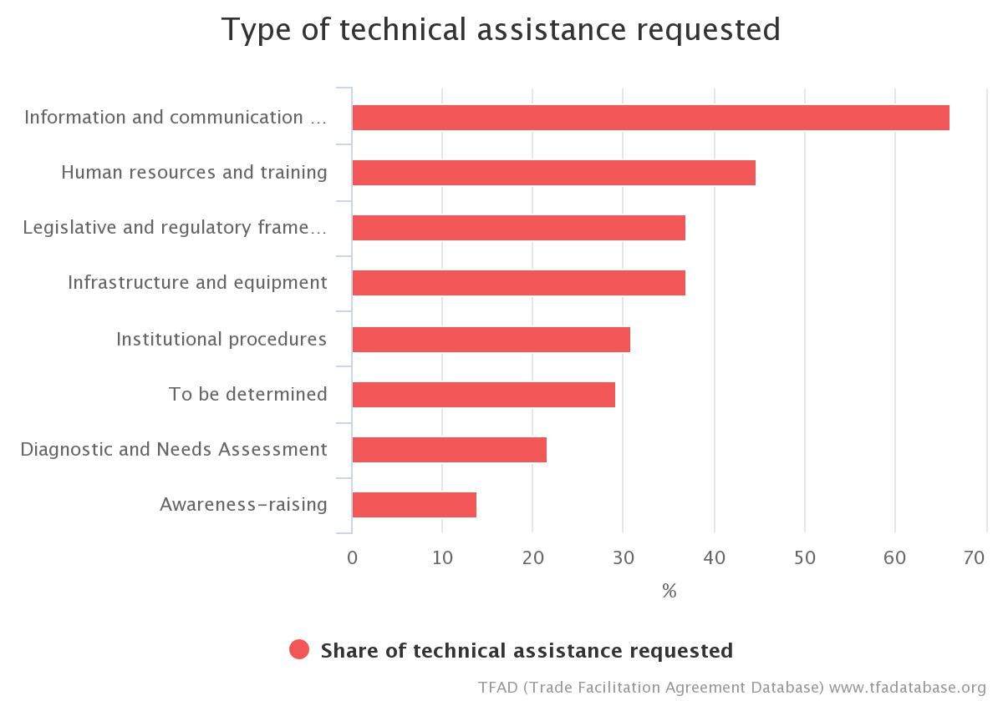
Article 10.4 Chart

Article 10: Formalities Connected With Importation, Exportation And Transit

5. Pre-shipment Inspection
Quick Summary Notes
What activity does this measure regulate?
Use of pre-shipment or destination inspection firms to carry out customs-related controls on imported goods
What authorities are directly concerned?
- Revenue Authority
- Customs
What is the new requirement?
- If a Member presently requires pre-shipment inspection of imports in relation to tariff classification or customs valuation, it shall end such requirements
- Members are encouraged not to introduce any such pre-shipment inspection requirements in the future.

Examples of TACB from Member Notifications: TOGO
- Training of customs officers in scanner management techniques.
- Transfer of competence (Cotec, Cotecna) to customs officers.
- Training of valuation and tariff division personnel.

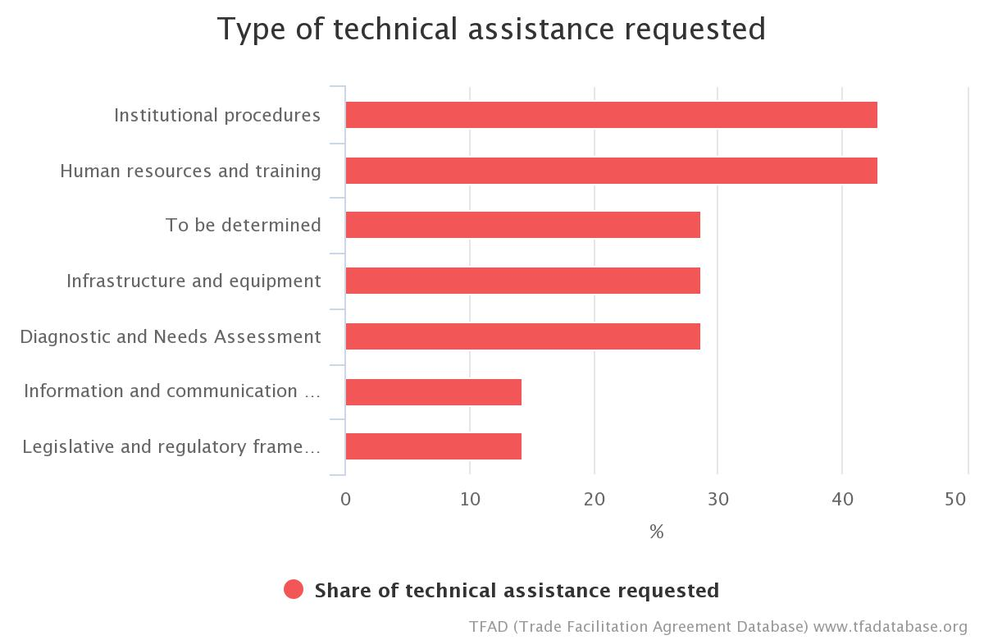
Article 10.5 Chart

Article 10: Formalities Connected With Importation, Exportation And Transit

Use of Customs Brokers
Quick Summary Notes
What activity does this proposal regulate?
The use of customs brokers in import, export or transit operations
What authorities are directly concerned?
- Customs
What is the new requirement?
- Members shall not introduce the requirement for the mandatory use of customs brokers.
- Measures on the use of customs brokers, or any subsequent modifications thereof shall be notified to the Committee and published promptly.
- Any broker licensing rules shall be transparent and objective.

Examples of TACB from Member Notifications: KYRGYZ REPUBLIC
- Study the possibilities of submission of electronic customs declarations through alternative information systems, including international practice
- Develop a mechanism of providing access for importers/exporters to information systems of customs authorities
- Train personnel
- Conduct awareness campaigns

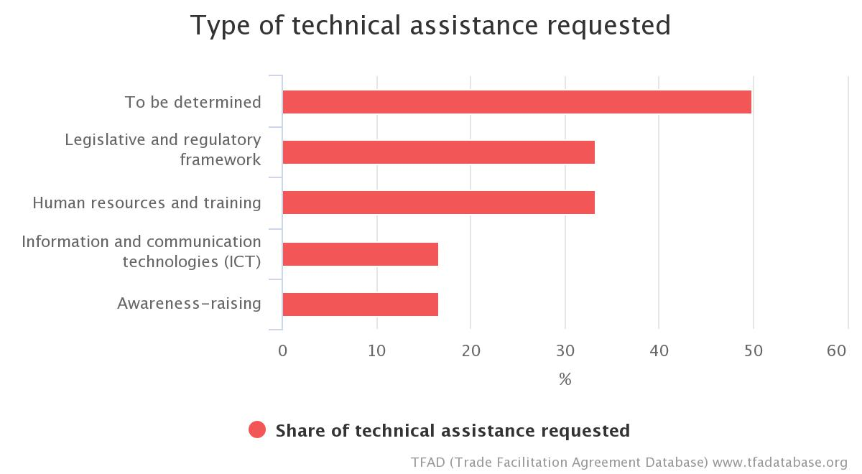
Article 10.6 Chart

Article 10: Formalities Connected With Importation, Exportation And Transit

Common Border Procedures and Uniform Documentation Requirements
Quick Summary Notes
What activity does this measure regulate?
The import/export procedures applied by Customs, and documentation requirements, at the different entry and exit offices within the customs territory
What authorities are directly concerned?
- Customs
What is the new requirement?
- Customs shall apply uniform documentation requirements and uniform release and clearance procedures.

Examples of TACB from Member Notifications (for 10.7.1 only): PAKISTAN
Modules Development, software, IT Support, HR Development.

Examples of TACB from Member Notifications: PANAMA
Technical assistance and support to streamline and optimize border processes and procedures with all institutions in order to ensure improved controls, eliminate unnecessary formalities and harmonize requirements for safeguarding international good practices.

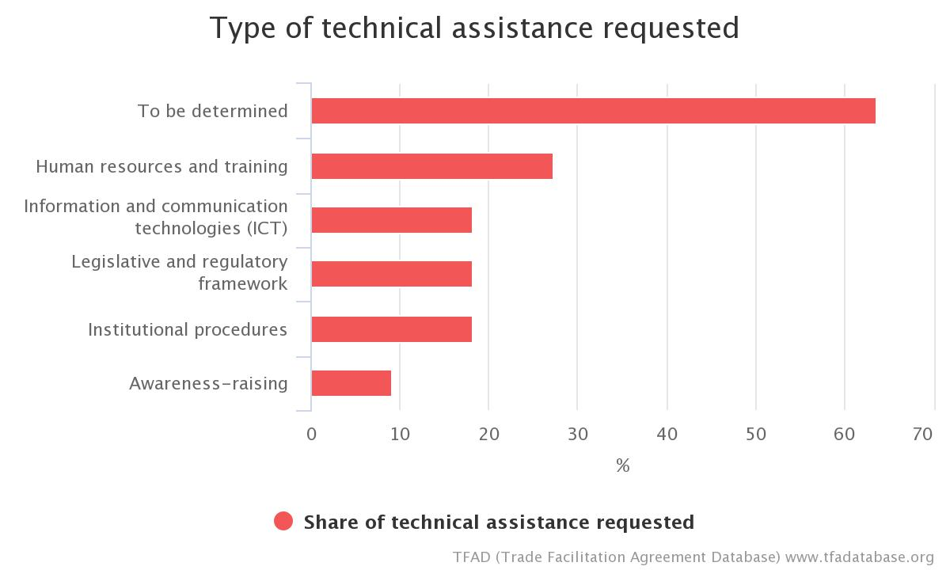
Article 10.7 Chart

Article 10: Formalities Connected With Importation, Exportation And Transit

Rejected Goods
Quick Summary Notes
What activity does this proposal regulate?
The re-export or return of imported goods that have been rejected by government authorities
What authorities are directly concerned?
- Customs
- Other Border Agencies (particularly, the Food Safety authority)
What is the new requirement?
- The importer shall have the right to return to the exporter, or any other person, imported goods that have been rejected by competent authorities due to failure to comply with prescribed Sanitary and Phytosanitary regulations or technical regulations

Examples of TACB from Member Notifications: DOMINICA
- Legal Guidelines for the procedure and disposal of rejected goods to be developed and implemented by the relevant Agencies e.g. Divisions of Agriculture, Bureau of Standards and the Environmental Health Unit among others

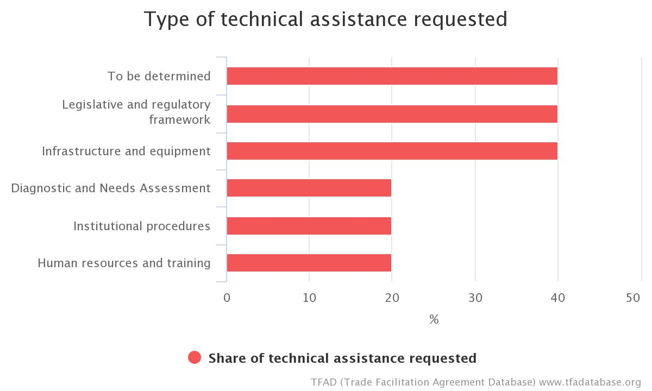
Article 10.8 Chart

Article 10: Formalities Connected With Importation, Exportation And Transit

Temporary Admission of Goods and Inward and Outward Processing
Quick Summary Notes
What activity does this proposal regulate?
Customs procedures to allow the importation of goods without payment of import duties and taxes, or eligible for duty drawback, subject to conditions on the use to which the goods have been, or will be, put.
What authorities are directly concerned?
- Customs
- Revenue Authority
What is the new requirement?
- Members shall adopt customs procedures for the temporary admission, inward processing and outward processing of goods.

A temporary admission procedure allows goods to be imported for a limited period of time (six months, one year, etc.) for defined purposes (e.g., goods to be displayed at trade exhibitions; shipping containers imported to be filled; tools needed for a domestic manufacturing operation; traveller’s personal effects; foreign-registered automobiles used by visitors to the country, etc.) without payment of import duties and taxes.
Manufacturers use the inward processing procedure for goods that have been returned to them for repair or for parts, materials, or other production inputs they use in their processing operations. Under the procedure, the goods may be imported without payment of duty or taxes provided the manufacturer exports the repaired or finished product within a specified period. Or duty may be refunded under a duty drawback scheme once the goods are exported.
Outward processing allows persons to send domestic or previously-imported/duty-paid goods abroad for purposes of repair (for example, goods returned to the manufacturer under warranty) or for other processing, and re-import the repaired or processed goods within a fixed period of time without payment of import duty or taxes, with the exception of duty or tax assessed on the value-added by the foreign processing operation.

Examples of TACB from Member Notifications: BELIZE
- Technical assistance to provide specialized training. Lack of trained officers in supervision and audit of manufacturing operations.

Examples of TACB from Member Notifications: MAURITIUS
- Services of consultant is required to assist in the design and establishment of an outward Processing Scheme at Customs.
Examples of TACB from Member Notifications (10.9.2 only): SEYCHELLES
- Seeking support to develop Regulations and standard operating procedures (SOPs) to facilitate the implementation of the provisions;
- Technical assistance and capacity building to configure the ASYCUDA World system.
- Training of Customs officers to facilitate the establishment and implementation of inward and outward processing.

Examples of TACB from Member Notifications: MAURITANIA
- Benchmarking study tour
- Training on supervising and verifying manufacturing operations for inward processing regimes
- Module on managing production records for the monitoring of inward processing
- Implementation of module on managing exemptions and temporary admission
- Capacity building
- (WCO)

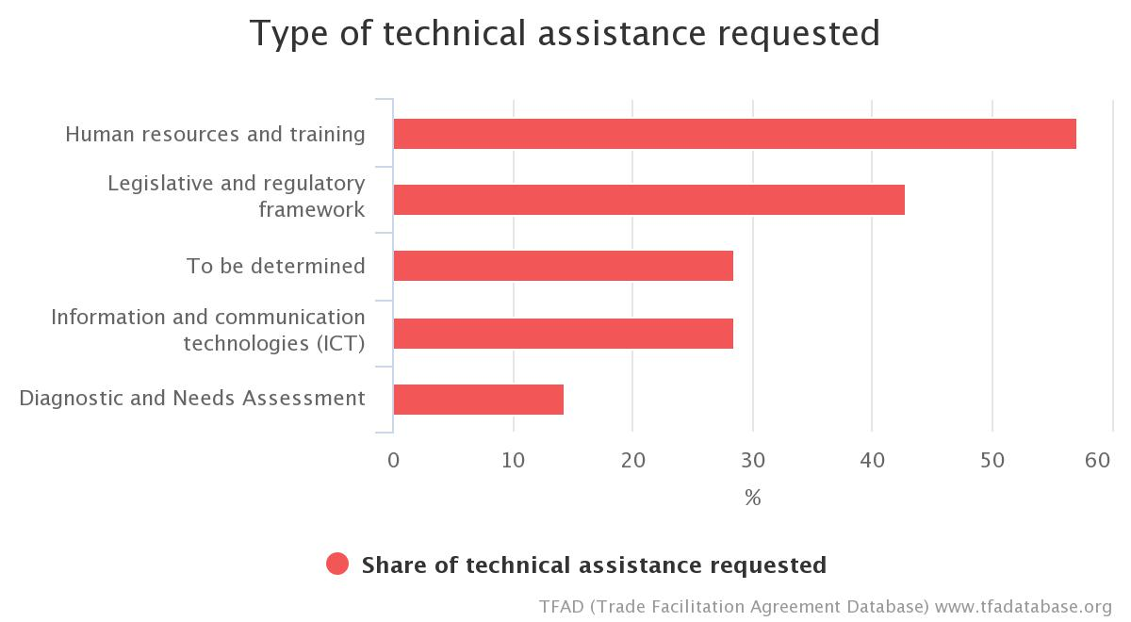
Article 10.9 Chart

Article 11: Freedom of Transit
Quick Summary Notes
What activity does this proposal regulate?
The regulations and formalities that a Member applies to traffic in transit
What authorities are directly concerned?
- Customs
- Other Border Agencies
What are the new requirements?
- Regulations or formalities on transit shall be eliminated or reduced if no longer required or a less trade-restrictive solution becomes available, and they should not be applied in a manner that would be a disguised restriction on trade
- Charges that may be imposed on transit only for transit administrative procedures entailed or transit services provided, and shall be limited in amount to the expense of such procedures or cost of such services
- Members shall not seek, impose or maintain voluntary restraints or similar measures on traffic in transit

Examples of TACB from Member Notifications: BELIZE
Article 11.1-11.3
- Comprehensive study and review of other fees and charges. Technical assistance needed for comprehensive study and review.
Article 11.6-11.17
- Technical assistance to facilitate comprehensive review/study and draft a Legal text. Comprehensive review and analysis of viability and benefits of membership into SIECA (Include a clause to address cross border transit issues).

Examples of TACB from Member Notifications: JAMAICA
Article 11.1-11.3
- Technical Assistance and Capacity Building (TACB) supported is required to:
  - Ensure that cost apportionment is accurate;
  - Train personnel in appropriate methodology to assess the trade impact of transit fees.

Examples of TACB from Member Notifications: NIGERIA
Article 11.5
- Provision of infrastructure to ease movement of traffic goods.
- Support for corridor monitoring exercises.
- Trainings on treatment of transit goods.
Article 11.12
- Training for cooperation and coordination amongst regulatory agencies.
- Customs procedures on transit.
Article 11.13
- Training for inter-agency coordination.
- Customs procedures on transit.

Examples of TACB from Member Notifications: BANGLADESH
Article 11.5
No development partner has so far offered any assistance in the area of traffic-in-transit (establishing separate physical infrastructure for traffic-in-transit).
Assistance required:
- Consultation with stakeholders through workshops, seminars and round table meetings
- Training
- Capacity development
- Development of Integrated Transit Policy

Article 11.9
No development partner has so far offered any assistance in the area of traffic-in-transit (allowing advance filing and processing of transit documentation and data prior to arrival of goods under traffic-in-transit).
Assistance required:
- Support for legislation
- Consultation with stakeholders through workshops, seminars and round table meetings
- Training
- Capacity development.
- Development of Integrated Transit Policy

Article 11.16
- No donor agency is working on this measure, so support is required
- Assistance is required for Development of Integrated Transit Policy

Examples of TACB from Member Notifications: GEORGIA
Acceding the conventions on Simplification of Formalities in Trade and Goods (SAD), Common Transit Convention (CTC) and implementation New Computerized Transit System (NCTS):
- Providing advice and recommendations in order to draft the relevant guidelines for the implementation of new regulations of Customs law with regards to transit; review and follow-up of all necessary legal, administrative and procedural arrangements;
- Providing assistance in setting up a team responsible for the implementation of the business processes and a team responsible for the IT aspects aiming at the implementation of NCTS;
- Providing assistance in elaborating Business Process Models (NCTS-Core Business: normal and simplified procedures; enquiry; and recovery procedure; guarantee management; fall-back procedure; trade related data, management (authorization)
- Providing assistance in elaborating functional specifications for Transit Module: specifications of all the business requirements concerning the core- business of NCTS; specifications of all the business requirements concerning the guarantee management of NCTS; specifications of all the business requirements concerning enquiry and recovery procedure of NCTS; specifications of all the business requirements concerning management of authorizations; specifications of all the business requirements concerning risk- management for NCTS; specifications for all the business requirements concerning fall-back procedures in NCTS;
- Establishment of Trade Awareness Policy;
- Training for Customs Staff; ToT

Examples of TACB from Member Notifications: MOLDOVA
- Implementation of the TWINNING Program for the New Computerized Transit System (NCTS);
- Implementation of electronic and simplified procedures for transit operations;
- Modernization of the Integrated Information System of the Border Police;
- Improvement of border crossing infrastructure to provide separate lanes, signalling and equipment required for priority transit.

Examples of TACB from Member Notifications: KYRGYZ REPUBLIC
Article 11.5-11.14
- Analysis of transit procedures with possible amendment of existing legislation
- Analysis of international laws and practice on guarantee
- Develop and implement procedures for acceptance of guarantees in electronic format
- Develop and implement a mechanism of insurance and guarantee

Article 11 Chart

Article 12: Customs Cooperation
Quick Summary Notes
What activity does this proposal regulate?
Customs-to-Customs exchange of information for purposes of verifying goods declarations
What authorities are directly concerned?
- Customs
What are the new requirements?
One Member shall provide another, upon request and subject to conditions, information and/or documents concerning specific import or export declarations.

Examples of TACB from Member Notifications: NIGERIA
- Training on cooperation with counterparts of other countries.
- Capacity building to review compliance of Nigeria customs law and practice with the provisions of this Article.

Examples of TACB from Member Notifications: SAINT KITTS AND NEVIS
Article 12.7.1
- Procedures – technical assistance to develop necessary procedures that ensures effective notification.
Article 12.7.2
- Legislative Drafting/Amending of all legislation applicable such as Customs and Excise Administration Act, and document privacy legislations in order to facilitate information sharing with Members while protecting Information credibility and confidentiality;
- Institutions - technical assistance to build capacity in relevant border agencies in order to implement and facilitate information sharing systems and protocols.
Article 12.9.1
- Procedures - development of efficient procedures in order to facilitate and implement information sharing system at the Regional/International level;
- Institutions - technical assistance to build capacity in relevant border agencies in order to implement and facilitate information sharing systems and protocols;
- ICT –assistance to ensure reasonable to high level access to IT equipment's especially for other border agencies.
Article 12.9.2
- Procedures - development of efficient procedures in order to facilitate and implement information sharing system at the National /Regional/International level;
- Institutions - technical assistance to build capacity in relevant border agencies in order to implement and facilitate information sharing systems and protocols;
- Human Resources/Training capacity building needed for relevant border agency Officials and business community to be sensitised, equipped and trained in order to implement information system;
- ICT – assistance to ensure reasonable to high level access to IT equipment's especially for border agencies.

Examples of TACB from Member Notifications: SAINT KITTS AND NEVIS
Article 12.1
- Policy - Development of a Policy for the Enhancement of Customs Control
Article 12.2
- Policy - Development of a Policy for the Enhancement of Customs Control
Article 12.3
- Policy - Development of a Policy for the Enhancement of Customs Control
Article 12.4
- Policy - Development of a Policy for the Enhancement of Customs Control and for information requests
Article 12.5
- Policy - Development of a Policy for the Enhancement of Customs Control and for information requests
Article 12.6
- Policy - Development of a Policy for the Enhancement of Customs Control and for information requests
Article 12.7
- Legal/ Policy – Revision of Customs Act and Data Protection Act to ensure TFA provisions are covered; development of a Policy for the Enhancement of Customs Control and for information requests.
Article 12.8
- Legal/ Policy – development of a Policy for the Enhancement of Customs Control and for information requests
- Human Resource/Training – fill staff vacancies
- Procedural – Revision of Business Process Management
Article 12.9
- Legal/ Policy – development of a Policy for the Enhancement of Customs Control and for information requests
- Human Resource/Training – Train personnel
- Procedural – Revision of Business Process Management
Article 12.10
- Policy - Development of a Policy for the Enhancement of Customs Control and for information requests
Article 12.11
- Policy - Development of a Policy for the Enhancement of Customs Control and for verification procedures

Examples of TACB from Member Notifications: UKRAINE
Technical assistance (advisory support and training) and ICT support for implementation request system.

Examples of TACB from Member Notifications: KYRGYZ REPUBLIC
Article 12.2-12.7
- Study international experience on exchange of information between customs agencies
- Review existing legislation and if required, introduce changes into the legal framework
- Examine the possibility of customs information system to verity declarations
- Monitor the practice of protection and confidentiality, provision of information and postponement or refusal of a request

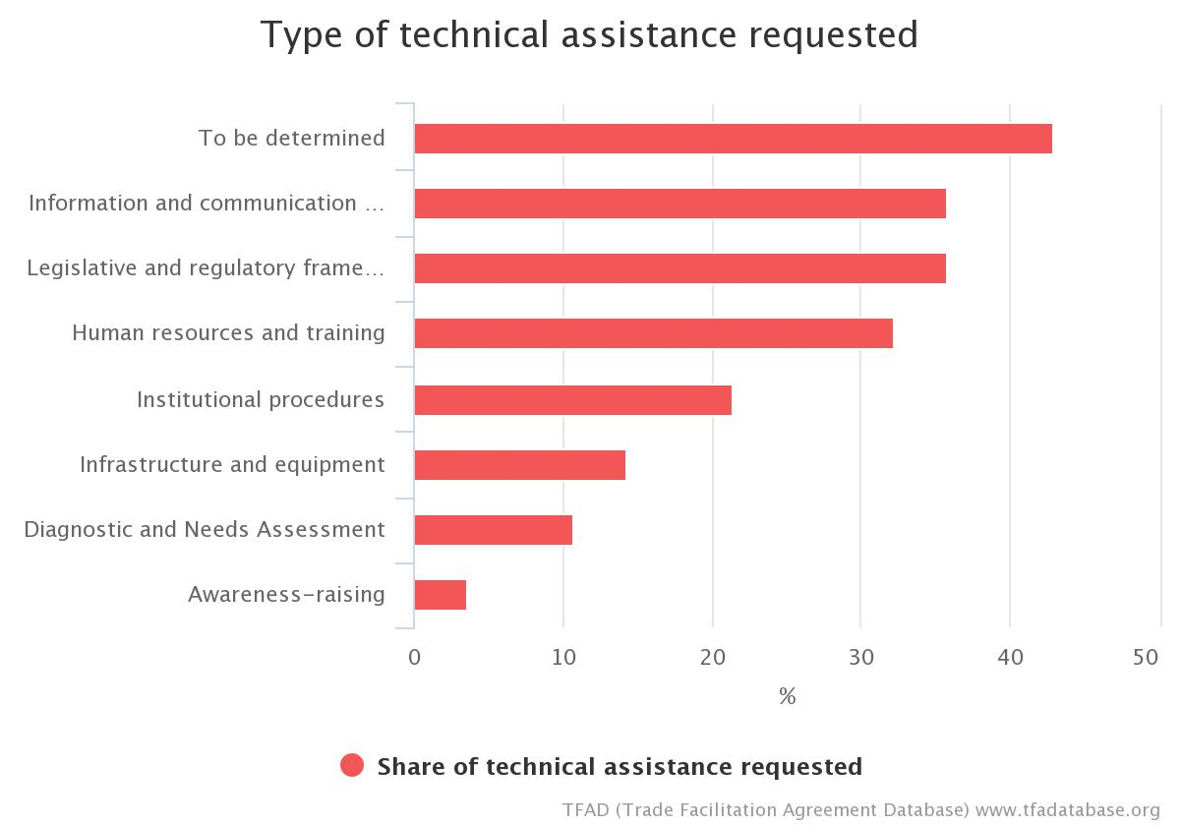
Article 12 Chart

